**Renter Solution: Messaging Application for Tenants, Landlord, and Agent in Ireland**

Dissertation submitted in part fulfilment of the requirements

for the degree of

MSc Information Systems with Computing

at Dublin Business School

Jigar Deepak Patel

**10364229**

MSc Information Systems with Computing 2017-18

**Declaration:**

I, Jigar Deepak Patel, declare that this research is my original work and that it has never been presented to any institution or university for the award of Degree or Diploma. In addition, I have referenced correctly all literature and sources used in this work and this work is fully compliant with the Dublin Business School’s academic honesty policy.

Signed: Jigar Deepak Patel

Date: 20/08/2018

Acknowledgement:

Abstract:

**Table of Contents:**

Chapter 1: 1

1.1 Introduction: 1

1.2 Research Question: 2

1.3 Practical benefits of the research and mobile chat application: 2

1.4 Dissertation Roadmap: 3

1.5 Scope of the research: 4

1.6 Limitation of the research: 4

1.7 Major contributions of this research: 4

Chapter 2: Literature Review 5

2.1 Residential Tenancies Act of Landlord and Tenant Law: 5

2.2 Doctor and Patient chat application in Android Operating System: 7

2.3 Bluetooth based Android chatting application: 8

2.4 Intranet based chatting application: 11

2.5 Comparison to existing chat application: 13

2.5.1 Introduction: 13

2.5.2 Existing chat application: 14

2.5.2.1 WhatsApp: 14

2.5.2.2 Viber: 14

2.5.2.3 Google Allo: 16

2.5.2.4 Comparison to Renter Solution application: 17

2.6 Complaints lodges to RTB regarding tenancy: 18

2.7 Literature Conclusion: 18

Chapter 3: Research Methodology and Methods 19

3.1 Introduction: 19

3.2 Research Design: 19

3.2.1 Philosophy of Research: 19

3.2.2 Research Approach: 21

3.2.3 Strategy of Research: 22

3.3 Limitations of Methodology: 23

Chapter 4: Artefact Design and Implementation 24

4.1 Introduction: 24

4.2 Software Development Life Cycle (SDLC): 24

4.2.1 Prototype model advantages: 26

4.2.2 Prototype model disadvantages: 26

4.3 Requirements: 26

4.3.1 Functional Requirements: 26

4.3.2 Non-functional Requirements: 28

4.3.3 Minimum Android System Specification: 28

4.4 Artefact Design: 29

4.4.1 Introduction: 29

4.4.1 System Architecture: 29

4.4.2 Use-case Diagram: 30

4.4.3 Class Diagram: 31

4.4.4 Sequence Diagram: 32

4.4.5 Renter Solution App Layout design: 35

4.5 Implementation of Artefact: 41

4.5.1 Introduction: 41

4.5.1 API: 41

4.5.2 Working of Renter Solution Application: 43

4.6 Limitation of Implementation: 49

Chapter 5: Data Analysis and Findings 50

5.1 Introduction: 50

5.2 Survey Results: 50

5.3 Interpretation of Results: 59

5.3.1 Choice of Android: 59

5.3.2 Issues between tenants, agent, landlord: 59

5.3.2 Communication gap factor: 60

5.3.3 Audio Interview: 60

Chapter 6: Research Discussion 61

6.1 Discussion: 61

6.2 Recommendation: 62

Chapter 7 63

7.1 Conclusion: 63

7.2 Future Scope: 64

7.3 Self-Reflection: 64

References 66

Appendices: 70

Appendix A: Definition of Terms 70

Appendix B: Questionnaire 71

**List of Table of Figures:**

**Figure 1: Doctor-Patient Chat Login** (Sonwane, et al., 2017) 7

**Figure 2: Pairing process of the Bluetooth** (Mahajan, et al., 2014, pp. 712-717) 8

**Figure 3: Client interface** (Verma, et al., 2013) 11

**Figure 4: List of active users on client side** (Verma, et al., 2013) 11

**Figure 5: Total number of smartphone users around the world 2014 to 2020** (Statista, 2016) 12

**Figure 6: Chat Interface** (Phoneia, 2018) 13

**Figure 7: Viber chat interface** (Viber, 2018) 14

**Figure 8: Chat Interface of Google Allo** (Miller, 2016) 15

**Figure 9: A framework for Research Design** 19

**Figure 10: Types of Worldviews** (Creswell, 2009) 20

**Figure 11: Inductive Approach** (Rubio, 2015) 21

**Figure 12: Prototype Model** 24

**Figure 13: Renter Solution System Architecture** 28

**Figure 14: Use-Case Diagram** 29

**Figure 15: Class Diagram** 30

**Figure 16: Sequence Diagram for Signup** 31

**Figure 17: Sequence Diagram for Login** 32

**Figure 18: Sequence Diagram for Create Group** 33

**Figure 19: Login Interface** 34

**Figure 20: Signup Interface** 35

**Figure 21: Group Chat Display Interface** 36

**Figure 22: Help Interface** 37

**Figure 23: User-type Selection Interface** 38

**Figure 24: User Profile Interface** 39

**Figure 25: Login Page view and incorrect credentials** 42

**Figure 26: Select User-Type and Signup for Tenant** 43

**Figure 27: Landlord Signup (Left) and Agent Signup (Right)** 43

**Figure 28: Create group option only by Agent** 44

**Figure 29: Main page of Agent (Left), Landlord (Middle) and Tenant (Right)** 45

**Figure 30: Communication between landlord, agent, and tenant** 46

**Figure 31: Search and submit Rating to the user** 47

**Figure 32: Search User (Left), Add User (Middle), Remove User (Right)** 48

**Figure 33: Users of Android Operating System** (Statcounter, 2017) 58

# Chapter 1:

## Introduction:

In recent years, Ireland has encountered a great increase in the number of International students and it is one of the hottest destinations to study abroad. As there are many famous universities and colleges like Dublin Business School, Trinity College Dublin, University College Dublin etc. and famous multinational companies like Google, Facebook, Apple, etc. which attract students and professionals to come to Ireland. There are a lot of other reasons like, English speaking country, similar lifestyle like UK, work visas after graduation for example 2 years of work visas for Indian students, and no tension about Brexit (Istead, 2017). According to O'Brien (2017), there is a significant increase in the application of international students to Irish universities and most of them are non-EU. Universities has encountered increase in the number of applications in which University College Cork (UCC) had 40% and University College Dublin (UCD) had 26% of increase and non-EU students are mostly from the countries like India, China, United States of America and Canada (O'Brien, 2017). Since the number of students have increased, there will be a problem for them to search accommodation into their budget and time.

Currently, Ireland is facing housing crisis which is directly affected to the people looking to rent an apartment. The average time taken to find a proper accommodation in Ireland is usually between one to two months, but some may find it earlier. According to Lyons (2017), the rental market conditions showed by Daft.ie rental report in September 2017, was in bad state. The rent in other parts of the country has approximately risen by 45%, but at the same time, there was approximately 70% increase in rents in Dublin (Lyons, 2017). The reason to increase the rent at a faster rate is because of the lack of property supply, and in this situation, landlords will be in a great profit if they rent out their apartment. In the month of August 2017, property available to rent throughout Ireland were less than 3000 and was 20% down as compared to the previous year which happened for the first time in Ireland history. There were 4800 properties available to rent nationwide and almost half of the property was in Dublin at a time in early 2007 (Lyons, 2017). In 2017, there were roughly 1000 properties available to rent and that is because, the rent has increase by 50%. As this rental crisis was never known before, this will directly have linkage to the homelessness crisis which will eventually affect the students. In such crisis, if the tenants get an eviction notice from the agent or landlord, it is very difficult for tenants to search and shift into new apartment.

After a lot of difficulties in viewing of unaffordable and unacceptable apartments due to the housing crisis, the renter finds one apartment finally to shift. Even after finding the correct apartment, there are lot of issues in that apartment that you won’t be able to see through your naked eyes. To solve those issues, the tenants should first contact house agent and explain the problems, and then the agent will contact the owner of the house to seek permission whether to make any changes or repairs in the house. So basically, there is a communication gap between house tenants, agent and landlord. To overcome this communication gap between the house tenants, agent, and landlord, this application can be used as a medium to report house related issues and convey the message to the correct person. This will help to save a lot of time and get the work done much quicker.

## Research Question:

**How can we reduce the communication gap and housing problems faced by renters in Ireland using mobile messaging application?**

Through this research, primary aim is to reduce the communication gap between the landlord, agent and tenants which leads to disputes between them and eventually eviction notice to tenants. The artefact implementation of this research will help all the renters regardless if they are international students or local renters to report house related problems like, if the window or window curtain rod is broken, plug point not working properly, heating system failure etc. to the owner of the house or agent directly using the user specific messaging mobile application. This mobile chat application will also be a medium for landlord, tenants and agents to solve the disputes between them. All the information regarding the Rights and Obligation for landlord and tenant, and dispute resolution information website links is added under “HELP” section, which will prevent all the users to go outside of the mobile application to hunt for information. There will also be an option for house agent or landlord to rate the tenants of the house according to their behavior.

## Practical benefits of the research and mobile chat application:

* As this mobile chat application will help to reduce the communication gap between landlord, tenant and agent and help them to resolve any dispute.
* The house agent and owner can manage more than one house by creating separate groups and adding tenants in the respective house groups this mobile application.
* Tenant can only be added by the house agent in the respective group, as tenants can only stay in one house.
* As a tenant point of view, reporting house related problems by clicking picture is added on the chat application.
* Agent can upload legal documents of the house on the group with tenants and landlord included.
* Agent or owner can schedule meeting with the tenants through group chat.
* An agent can rate a tenant on the application according to his behavior or any issue. This will help eliminate the need of the reference letter from the previous agent or landlord and only agent can search the username of a tenant to check the rating.

## Dissertation Roadmap:

The Dissertation is divided into different chapters and each chapter focuses on a particular area.

**Chapter 1** gives a brief introduction, background of the dissertation, details the problem and specifies the need of this study.

**Chapter** **2** is about the literature review. It explains different techniques to implement chat application that focuses on different industry and compares with existing chat application in the current market. It also discusses important facts about cases to RTB which are related to tenancy.

**Chapter 3** is about research Methodology and Methods used. It discusses about the research designs and approaches used for primary and secondary data collection.

**Chapter 4** is about the Artefact Design and Implementation. It discusses about the software model used during implementation and requirement analysis of the artefact developed. It illustrates the design and explains the working of artefact.

**Chapter 5** is Data Analysis and Findings. It discusses about the results of the findings through questionnaire and audio interview, and interpretation of the data collected related to this research.

**Chapter 6** talks about the research discussion.

**Chapter 7** talks about the conclusion. It assesses how aim and objective of this research is achieved. Also, it talks about future scope, reflection and learning from this research study.

## Scope of the research:

* This research is focused in designing and implementing a mobile chat application on Android platform and focusing on specific users such as landlord, tenants, and agent.
* The mobile application must be able to send, receive messages, search, and rate a specific user i.e. a tenant.
* This research will also provide information related to tenant and landlord law, effects of housing crisis on renters, and information regarding Threshold and RTB.

## Limitation of the research:

* The development of the mobile application is vast and has several dimensions. So, it’s very difficult to cover all the aspects of mobile development in a single research.
* Currently, there are many mobile OS like iOS, Android, Windows etc. available, so implementing the chat application for every OS is difficult.
* Posting a feedback for a user by another user is difficult and storing the feedback data in backend is also challenging. This feature will require more time to implement and will be available in version 2 of the application.
* As this research is regarding the chat app for landlord, agent and tenant. The main goal is to send and receive messages from specific users. Hence, End-to-End Encryption (E2EE) for the messages has been neglected and is beyond the scope of this research.

## Major contributions of this research:

This research highlights the relationship between an agent, tenants, and landlord. It discusses the effects of housing crisis, disputes, and the need to resolve the communication gap between landlord, tenant, and agents. It also discusses that, through the implementation of a mobile chat application, communication gap will decrease and hence there will be less cases filed to RTB. Ultimately, this research will contribute and improve the relationship between landlord, agent, and tenants.

# Chapter 2: Literature Review

## Residential Tenancies Act of Landlord and Tenant Law:

As this research is regarding the tenancy application, landlord and tenants should be aware of the basic laws and amendments done to the previous Acts by RTB.

Currently, there is Residential Tenancies (Amendment) Act 2015 which has passed and signed into law on 4th December 2015 by the President (Baneham, 2015). Following are the amendments done to the previous Acts and stated in Act 2015 which are related to landlord and tenants.

* **Rent Increase:**

Baneham (2015), a Barrister at Law has discussed and prepared all the changes made to the previous Acts 2004 to 2009. In the case of rent increase, landlord must inform the tenants 90 days prior regarding rent increase in a prescribed form. The prescribed form will include justification to increase rent and compare three advertisements of rent in same area four weeks prior to the notice given (Baneham, 2015).

* **Termination of Tenancy:**

The base for tenancy termination is now very strict and stronger as compared to the Acts 2009 and 2004. The landlord needs to provide a termination or eviction letter in the case of tenant breach i.e. tenants in fault. Also, termination on the grounds of sale or occupying the apartment by landlord itself or any of his/her family member, landlord need to provide notice to tenants one month prior. And in case of refurbishment of the apartment, landlord should re-offer tenants to stay in that apartment after the work is done in six months period (Baneham, 2015).

* **Dispute Resolution:**

Residential Tenancies Act 2015 states additional categories for the issues that are related to dispute resolution. Additional category will include the failure of the landlord to return deposit amount to the tenants after their tenancy period. And failure of both the parties i.e. landlord and tenants to follow laws assigned to them (Baneham, 2015). The act also changes the cooling-off period of 21 days for resolution of the disputes to 10 days including weekends and bank holidays (Board, 2018).

The Planning and Development (Housing) and Residential Tenancies Act 2016 was passed and signed on 23rd of December 2016 by the President in which minor amendments are made to the Residential Tenancies Act 2004 which is related to both, landlord and tenants (Board, 2018). A landlord cannot terminate the lease contract or send eviction notice to vacant the apartment without any reason. If this happens, a tenant can lodge a complaint to RTB (Board, 2018). In the case of Anti-social behaviour by tenants, a landlord is liable to the distress caused to third-person (neighbour) (RTB, 2018). In Act 2016, which was changed on 9th May 2016, third-party i.e. affected person can now file a case against landlord and take the case to RTB. Other Act passed in 2016 related to landlord and tenant is Dispute Resolution. Telephone Mediation is a category in dispute resolution, which is now free (RTB, 2018).

## Doctor and Patient chat application in Android Operating System:

In Sonwane, et al. (2017, pp. 170-174) shows how doctor patient communication is done using android chat application. In that research, chat application is basically used for sharing data such as x-rays, ECG, blood reports, prescription etc. by the doctor with his/her patients. The implementation of this research shows that, the patient has to send request to the respective doctor, and then, communication is possible between them (Sonwane, et al., 2017), which is similar to this research.

In this research, specific users will also be using a chat application to communicate between them. Like doctor patient application, in this research implementation, agent will be the primary user who can add landlord and tenants in a home chat group. Only if agent adds the tenant and landlord, then communication can happen over application. If there is no agent in between, landlord can register as agent and login in which he/she can manage all houses. Sonwane, et al. (2017) uses technologies such as Firebase for backend and MySQL database to store information of the user. By this research, I found Firebase is used for all the back-end support for chat application which is simple and SDKs are already provided by Firebase. Also, user authentication i.e. OAUTH 2.0 is provided by firebase which will be automatically added when selecting an option. By this, the user can user Gmail or Facebook credentials to login to the app. Whereas in this research, all the users need additional information at first to sign-up, that’s why OAUTH cannot be used for sign-up in this application. 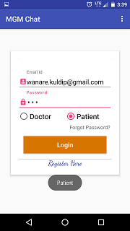

**Figure 1: Doctor-Patient Chat Login (Sonwane, et al., 2017)**

Figure 1 shows the login screenshot of the doctor patient application in which, the user must select either doctor or patient user-type (Sonwane, et al., 2017). But there will be no extra information collected from the user at the time of login such as disease type and doctor’s specialty category etc. which will be need by the doctor at a later stage, as mentioned in limitations (Sonwane, et al., 2017). Comparing the research implementation of Sonwane, et al. (2017) to implementation requirements in this research, doctor-patient requires limited information while registration of the users, which can be a drawback in future. Whereas, Renter Solution requires more details of the tenants, landlord and agents such as PSR (Property Services Regulatory) number of the agent, current address of the tenant and mobile number which is very important and hence won’t need any additional information in future. Also, there is a rating feature in the application where, an agent can rate tenants out of 5.

## Bluetooth based Android chatting application:

The authors Mahajan, et al. (2014, pp. 712-717) shows how a Bluetooth on an Android based smartphone can be used for chatting with another Android based smartphone. The author also explains that, most of communication happening in past was through China Unicom gateway which was paid service. To overcome this, author implements and uses Bluetooth technology of an Android device to communicate with other smartphones having Bluetooth using LAN, which help devices to communicate with each other without paying any cost (Mahajan, et al., 2014). The methodology used to implement is Bluetooth module, where in the case of two devices connected via Bluetooth, one device will be Server and another device will be client. Where there are more than two devices connected to each other, only one device will be server and rest will be clients and can only be added by server device (Mahajan, et al., 2014). The design of the chatting application is a Client-Server architecture. Bluetooth API is used where it provides RFCOMM (Radio Frequency Communication) channel to transmit data between the devices connected. Each Android device will have a unique MAC address, and using that, the server-side device will be able to discover and pair the client-side Android device (Mahajan, et al., 2014).

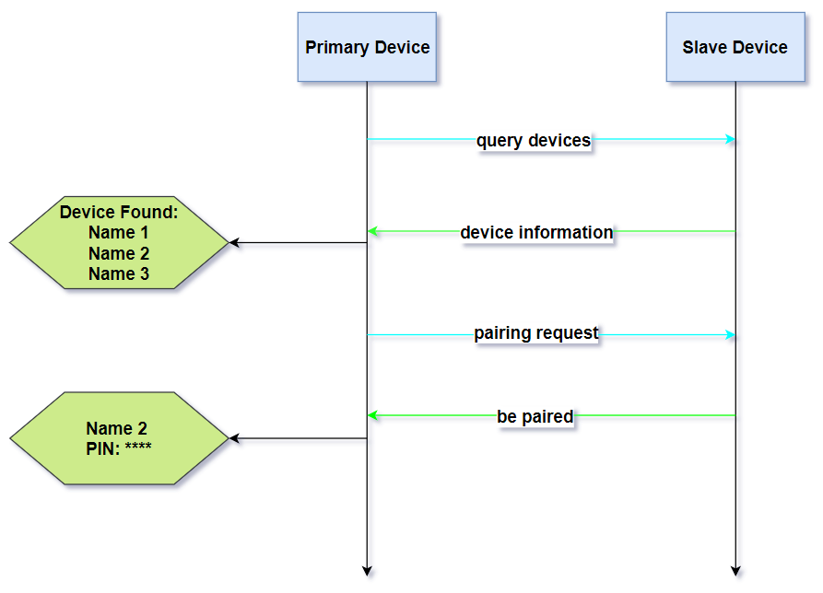

**Figure 2: Pairing process of the Bluetooth (Mahajan, et al., 2014, pp. 712-717)**

The author Mahajan, et al. (2014) explains the Bluetooth pairing process before establishing the chat session. Primary device i.e. Bluetooth server-side Android phone will enable Bluetooth and will be discoverable to other devices and can see all the slave devices with enabled Bluetooth. The server-device gets all the information of the available slave devices nearby and hence sending pairing request to device which it intends to communicate. The slave device will send a PIN number to primary device which has to match, if the PIN number matches then a connection is established between two devices where one device will be a server and other will be slave. Bluetooth communication is same as TCP (Transmission Control Protocol) traffic (Mahajan, et al., 2014).

Another research conducted by Ghare, et al. (2015, pp. 10674-10679) also shows how Bluetooth can be useful to chat with other devices. The research done by Mahajan, et al. (2014) and Ghare, et al. (2015) are similar to each other except for one feature i.e. chat history will be stored on a server which is done by Ghare, et al. (2015) in their research. The methodology used in both the researches are Bluetooth API’s which provides functions such as BLE (BT Low Energy) to scan other devices, Bluetooth Adaptor for enquiring paired Bluetooth devices and RFCOMM channel for establishing connection between the devices. The only similarities of these researches to my research is that, they use Client-Server Architecture to communicate between the users of the application.

These Bluetooth based chatting systems are useful where there is no Wi-Fi or internet available, but it has several limitations (Ghare, et al., 2015). The limitations are:

* The maximum range of the Bluetooth is not more than 100 meters. This is a major disadvantage of Bluetooth based chat application where it cannot communicate with another user if they are far.
* Bluetooth chat applications can only transfer small amount data over chat.
* The speed of chatting will be slow as compared to other non-Bluetooth chat applications.
* In Bluetooth communication, any device enabled with its Bluetooth can get connected to the server device.
* The bandwidth of the Bluetooth technology is lower than Wi-Fi and cellular connections.

As compared to the implementation of my research, Renter Solution chat application will take out the limitations of a Bluetooth based Android chat application. Renter Solution is a Client-Server based architecture where communication between users is not based on the Android Bluetooth. It relies on the cellular connection or Wi-fi to communicate with other users. Presently, cellular connection is very advanced and uses 3G/4G technologies which has worldwide coverage of the network. Hence, it provides faster data transfer rate as compared to Bluetooth. According to McDonald (2018), there are 4 billion Internet users. So, maximum people around the world has internet connectivity on their Android smartphones which eliminates all the users to be in any range and data transfer speed over the chat will be better. In Renter Solution application, only the agent has been given right to create group and add members. This will give assurance of no other stranger can get added to the apartment group unless he/she knows the agent or landlord.

## Intranet based chatting application:

In this research, the authors Mehrotra, et al. (2014, pp. 265-272) discusses about the Peer-to-Peer (P2P) chat application used in an organization without the need of cellular network on Android smartphones. They are connected to the Intranet of an organization over Wi-Fi. The author shows that, in an organization where all the employees needs to have meeting at the end of the day or during the work hours, so they have to gather in a room or chat via email to share the work reports and discuss about related projects (Mehrotra, et al., 2014). To avoid meeting physically or chat through emails, Mehrotra, et al. (2014) have proposed an idea of an Instant Messaging Android based application where more than one person can join the chat over internet which is connected to Wi-Fi in an organization. This Instant messaging chat application offers text-based quick transmission of messages from sender to receiver over intranet (Wi-Fi). The researcher uses BlueStacks App Player which is used to install and use Android applications on Windows PCs, Macintosh computers and Windows tablets by which all the users can use the application to chat with each other. The main aim of Mehrotra, et al. (2014) is to allow the users to communicate in an Intranet without paying any Internet data charge on Android phones. The architecture of the Instant messaging chat application is based on Peer-to-Peer (P2P) network and the developed service or application will be installed on the intranet server, through which all the users connected on the intranet can communicate with each other (Mehrotra, et al., 2014).

A similar study done by Verma, et al. (2013, pp. 1030-1032) says about the Intranet based messaging service on Android smartphones and tablets. It explains and demonstrate the implementation of their research. Following are the images of the implementation of Intranet Based Messaging service:

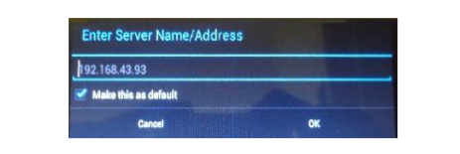

**Figure 3: Client interface (Verma, et al., 2013)**

The above image shows the client interface where the client specifies the server address, to connect with the organization server.

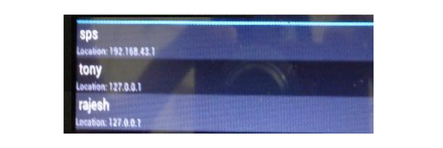

**Figure 4: List of active users on client side (Verma, et al., 2013)**

The above image shows when a client gets successfully connected to the server, the server broadcasts the list of active users and can communicate with other employees in the organization. All the information regarding the employees will already be stored in the organization server by the company (Verma, et al., 2013).

This research as compared to both the studies is not similar. The implementation of this research will be different, where the clients (users) i.e. tenants, landlord, and agent will send request to the server and server will then give response to the request sent by the users. Which indicates that, Renter Solution chat application will not be bounded by the server in which all the users are connected through same Wi-Fi. The chat application of this research will work on Wi-Fi network as well as cellular network as compared with the Intranet based Messaging Service (Verma, et al., 2013) and Instant Messaging Service on Android smartphones (Mehrotra, et al., 2014).

## Comparison to existing chat application:

### Introduction:

As the number of smartphones users around the world has increased and it is expected to rise more. Below is the image of number of the smartphone users around the world and prediction till the year 2020:

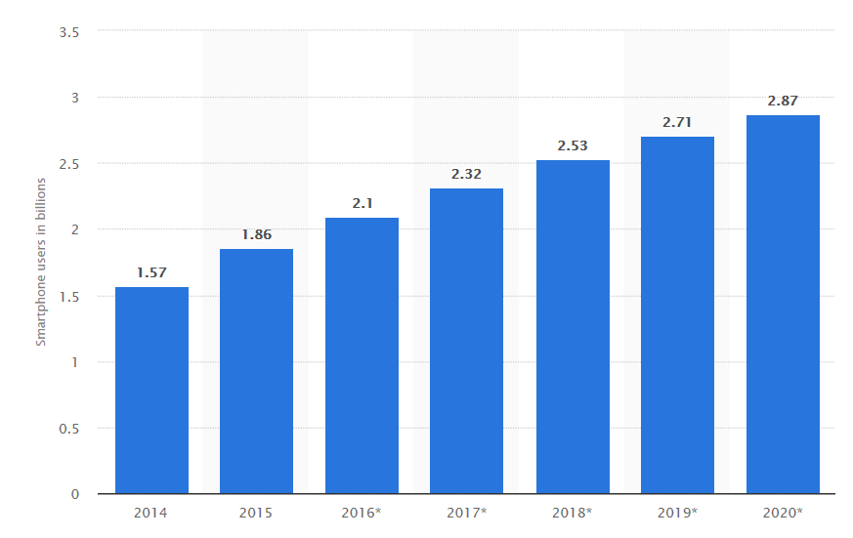

**Figure 5: Total number of smartphone users around the world 2014 to 2020** (Statista, 2016)

As the above images shows the number of smartphone users around the world from the year 2014 to 2020. By the year 2019, the number of smartphone users is expected to grow around 2.71 billion and by 2020 it will grow around 2.87 billion (Statista, 2016).

Since this research is regarding chat application, there are number of chat applications available in the mobile market to use. Earlier, every chat application was almost similar to each other but nowadays some chat applications in the market have started to differentiate themselves from other present chat applications.

### Existing chat application:

#### WhatsApp:

WhatsApp messenger is one of the most popular cross-platform chatting application that is used to exchange text, voice call, video call, share location, document, audio and contact over iOS, Android, Blackberry and Windows smartphones (WhatsApp, 2018). The users of the WhatsApp are more than 1 billion in 180 countries around the world which helps family and friend to stay in touch anywhere and anytime in the world (WhatsApp, 2018). Below is the image of the chat interface of WhatsApp in Android smartphones.

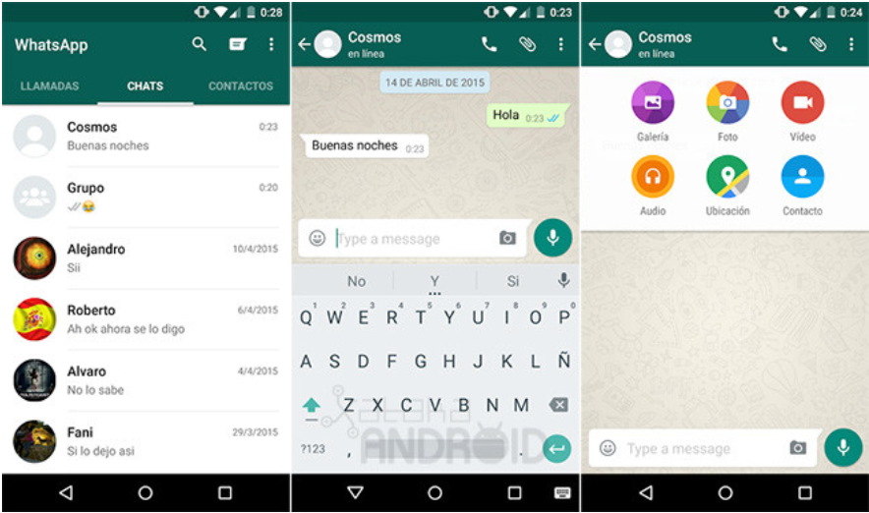

**Figure 6: Chat Interface** (Phoneia, 2018)

The chat interface of WhatsApp is very simple in design and user-friendly so that people can understand and use it easily. The protocols used by WhatsApp messenger are XMPP (Extensible Messaging and Presence Protocol) which is used for instant messaging between two or more users (Yasser, et al., 2017).

#### Viber:

Viber is a mobile chat application which provides endless options for expressing user’s mood through messaging and has variety of calling and messaging features (Viber, 2018). Viber supports video and audio recording, group chats, expressive stickers and, audio and video calls which can be used on iOS, Android, Windows phone and Windows10, Mac and Linux based devices (Viber, 2018). Below is the image of the chat interface of the Viber application:

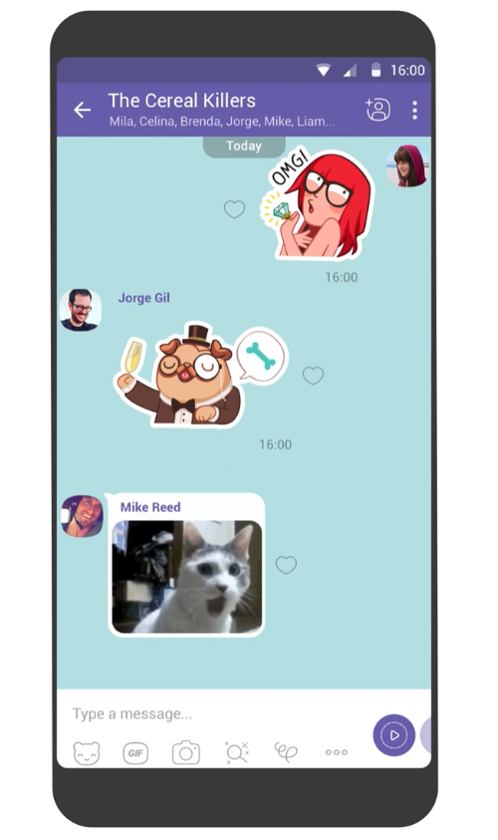

**Figure 7: Viber chat interface** (Viber, 2018)

The chat interface of Viber is unique and provides lot of options to express your mood. Various features of Viber are:

* The messages sent on Viber are End-to-End Encrypted which provides privacy to the application. You can hide a chat and access through PIN number, self-destruction messages and controls for when other see the status and delivery status of messages (Viber, 2018).
* Viber out is a feature that allows the user to call a non-Viber mobile or landline number from your contacts at very low rate. For that feature, the user must purchase Credit or Call plan (Viber, 2018).

The above feature makes Viber chat application stand out differently from other application in the market. The protocol used by Viber is VoIP (Voice over Internet Protocol) technology which allows the application to make high quality voice call by using broadband internet connection (Yasser, et al., 2017).

#### Google Allo:

Google Allo is also one of the most famous and popular chat messaging application in the market. Google Allo is available for iOS, Android devices and Web which can be used in any desktop or laptop. This application is developed by Google company and provides amazing features (Allo, 2018). Allo application has audio and video calls, audio and video recording, photo messaging and group chats (Allo, 2018) like existing chat applications. Below is the chat interface of Google Allo application:

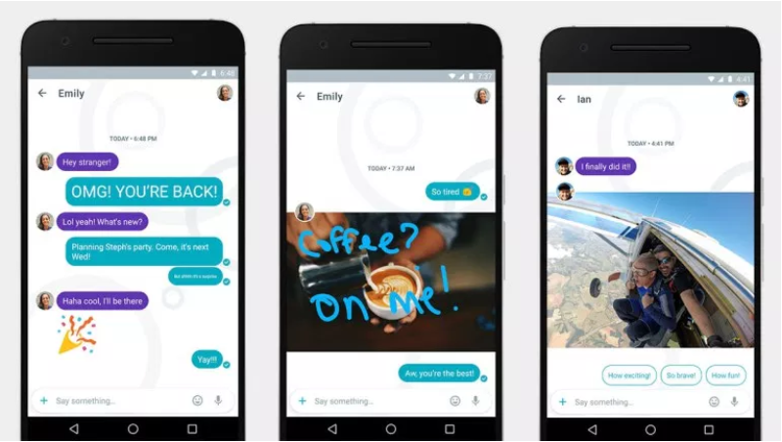

**Figure 8: Chat Interface of Google Allo** (Miller, 2016)

The user interface of this application is friendly and easy to use. Features that makes this application different from others are as follows:

* The user can respond without typing the message. Google Allo learns from the conversation and the way user texts (Allo, 2018).
* Allo has Google Assistant which helps the user whenever they need it. It helps you to stay in the conversation and search for things that the user wants to search (Allo, 2018).
* It has incognito mode in which all the messages are End-to-End encrypted and has self-destructive feature (Allo, 2018).

#### Comparison to Renter Solution application:

As there are many chat applications in the market, above are applications which are top 3 in the messaging business. The Renter Solution chat application is an implementation of this research study which is designed to be used by specific users such as tenants, landlord and agent only. This application will help all the users to communicate between each other and solve disputes. As the above-mentioned apps can also be used for communication between the users of Renter Solution application, but there are certain features that make the Renter Solution application different from the top 3 chat application of 2018 as mentioned above. The implementation and interface related details are explained in Chapter 4 in this research.

The Renter Solution application does not include all the features of the mentioned chat applications, but it has features that are different.

* Renter Solution uses XMPP protocol for chat feature and database is stored in MySQL.
* Renter solution application will only focus on specific users because, main motive to develop the application is to reduce the communication gap between them.
* The other feature of the application is that, it provides all the information that is related to the house, landlord, agent, and tenants.
* In the Help section, websites links are provided so that if the user is not sure or aware about his/her rights then, they can click the link and read it.
* Another feature is that, only agent has given right to create a chat group of a house, add tenants and landlord in that group.
* Agent can rate tenants of the apartment according to their behavior. This rating feature will reduce and slowly eliminate the need of reference letter when a tenant is searching for a new apartment. The new agent can request username of the tenant to check the rating given by old agent. The tenant can also rate according to cooperativeness and behavior of the agent and landlord.



## Complaints lodges to RTB regarding tenancy:

According to Ryan (2016), the number of complaints that has been lodged by the tenants against landlord for rent hike dispute has increased a lot in the middle of the worst housing crisis. According to the reports of the Residential Tenancies Board, there was an increase in the number of complaints logged by tenants for unfair rent hike by 70 percent as compared to previous year 2015 (Ryan, 2016). During the same period, there was also increase in the cases of illegal eviction by landlords on tenants. In 2014, Residential Tenancies Board dealt with 185 dispute cases that were only charging for rent higher than the current market rate, which in the year 2016 went to 313 cases. And in year 2017, during the first quarter of the year, number of cases already logged were 66 to Residential Tenancies Board (Ryan, 2016). But, there are number of tenants that does not lodge any complaint against landlord because they think, there will be time and money wastage. Threshold, a housing charity says*, “this is just the tip of the iceberg as most tenants do not lodge disputes with RTB”* (Ryan, 2016). In contrast, there are also many cases registered by the landlords against tenants who are denying to leave the house even if the lease agreement is over. In 2016, Residential Tenancies Board has registered 553 cases of disputes where tenants were defying eviction notices and, to the end of November 2017, the cases registered were 688 disputes which was 24.4 % increase in year 2017 as compared to previous year (Halpin, 2018). As landlords lodge complaint against tenant, RTB issues an eviction notice for the tenants which has to be followed. Halpin (2018) mentions that, many member of parliament has told the constituents to not issue an eviction notice to the tenants as, there is no place for them to shift unless and untill they find another house to stay. As these disputes are unpredictable, information regarding disputes and weblinks will be provided in the mobile application under Help section.

## Literature Conclusion:

In this section, the researcher has discussed regarding chat application developed on different technologies for specific purposes, compared the developed artefact to existing chat applications and discussed regarding law, and facts about complaints to RTB which are related to this study.

# Chapter 3: Research Methodology and Methods

## Introduction:

The objectives of this research were to investigate and provide a solution to the problem arising in Ireland regarding the accommodation issues, disputes, and lack of communication between the landlords, tenants, and agents. To achieve these objectives, there was a need to investigate about the problems which were implemented in stages in the form of Questionnaires and Audio Interview.

The main reason to choose questionnaire for primary data collection method is considering the privacy of the people involved in survey and is an affordable option. Stage one of the data collection method was questionnaire which were targeted to renters, landlords and agents in Ireland through which, the researcher was only able to get 101 responses, in which maximum were renters representing as International students. Second stage was taken into consideration when there was no reply from landlord and agents. After struggling, researcher managed to get an appointment from a Landlord who owned and managed number of houses in Ireland. The interview was regarding the existing cases and problems faced by him because of tenants. All the data collected from the questionnaire was analyzed using Microsoft Spreadsheet. The key to success to this research is to understand the perception of tenants who plays a major role. As the questions used in the survey primarily focused on accommodation related issues and how the issues were solved and helped to determine the current level of relations between the actors. This chapter will provide details about the methods used for research and why those methods were chosen.

## Research Design:

### Philosophy of Research:

According to Creswell (2009), design of the research is management of the procedures that are carried out for research which alters the decisions by broad view of hypothesis to detailed methods of data collection and data analysis. This has led the researcher to decide and select a research design to be used for a topic. According to Holden & Lynch (2004), the research should not be methodologically driven, rather, that methodology should be the significance of the investigation done by the researcher in the relevant area. With the investigation results, the researcher got an idea of how to progress with implementation of the research according to the requirement (Holden & Lynch, 2004). Creswell (2009) explains that there are three types of approaches for an effective research named Qualitative, Quantitative and Mixed Methods. Qualitative research is used to acquire information from a group of people or individuals regarding their thoughts about a social or human problem (Creswell, 2009).

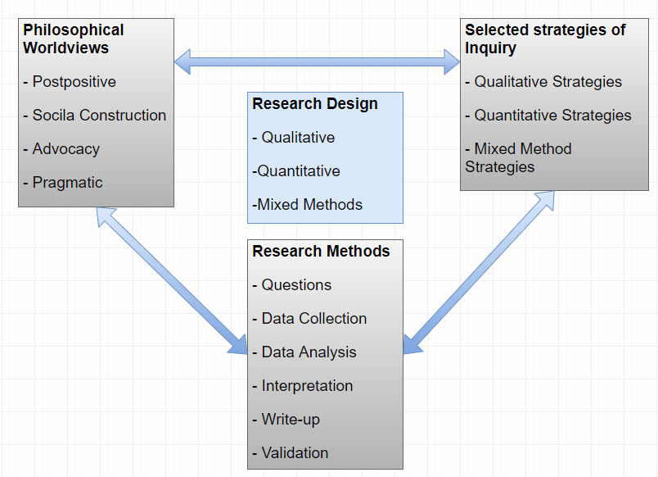

**Figure 9: A framework for Research Design**

The above figure illustrates the philosophical worldview of what the researcher make assumptions about the study, strategies to use for data collection related to the philosophical worldview and what procedures of research are being used to analyze and translate that into meaningful data related to the study (Creswell, 2009).

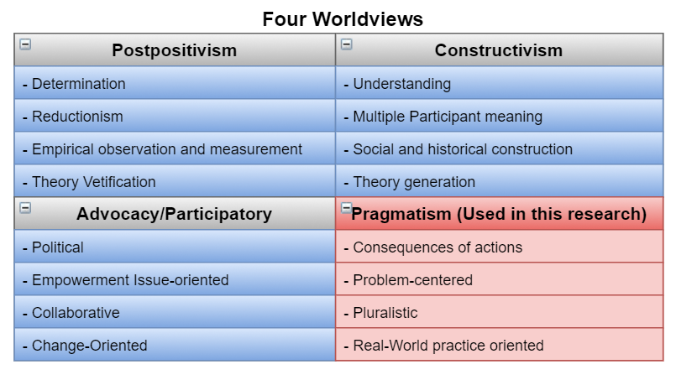

**Figure 10: Types of Worldviews (Creswell, 2009)**

The Research Design used in this study is Pragmatism. Pragmatism Worldviews is dealing with the actual problems in real-world and providing solution to that problem by the means of research approaches used (Creswell, 2009). The research strategy used for this research is Qualitative i.e. questionnaire and audio interview. Questionnaire provides information of what are the scenarios in real-world between landlord, agents, and tenants. And audio interview will provide the perception of an agent towards the problem.

### Research Approach:

The research approach used in this study is inductive. The researcher has started by collecting thorough information from a group of people or individuals related to the study and then divided the information into certain categories (Creswell, 2009). This inductive approach is following bottom-up approach. In this research, the researcher has first collected the information by interviews and questionnaire targeting the people related to this study. Once the data was collected, researcher has analyzed and recognized a broad pattern from that data. Using that pattern, the researcher has developed a tentative hypothesis of the study. The researcher has finally crafted the theory and conclusion of the study based upon that hypothesis. Below is the diagram of bottom up inductive approach followed in this research.

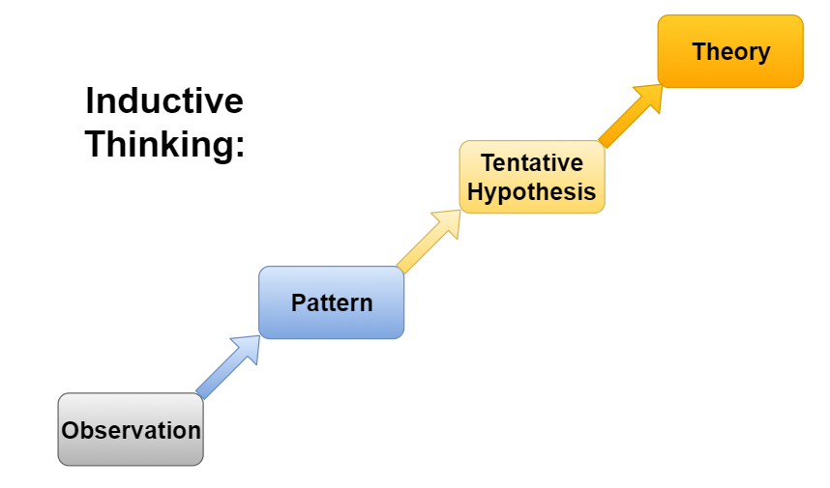

**Figure 11: Inductive Approach (Rubio, 2015)**

### Strategy of Research:

There are two main strategies that are used gather information. The subsection shows how the data was collected and which strategy was used.

1. **Questionnaire:**

For the survey, Google Forms were used to gather data from the targeted audience through questionnaire. The questionnaire was directed toward the tenants, agent, and landlord in Ireland and was circulated through social media. Below is the description of the question types used in questionnaire.

The questionnaire for survey was framed in such a format that, the respondents can express their thoughts and experience they faced. There were several types of questions used for the survey. The types of question are category, open-ended, close-ended, list, situational and rating question. Total **4 category questions** were used to collect demographic information of the respondents like age, gender etc. There were total **17 close-ended questions** which were used to collect specific information. For example, “do you feel there is any communication gap between tenants, landlord, and agents”. Total of **7 open-ended questions** were asked that helped the researcher to collect respondents experience regarding any issues faced. Total **2 list types of question** which were used to get specific answer from the respondents. There were **several situational questions** used to check what the respondent will do if given a situation and what is the awareness level of respondents. **One rating question** was used regarding the implementation of chat application developed. The questionnaire is provided in the appendices section.

1. **Audio Interview:**

Audio interview was conducted with a Landlord, when there was no response from any landlord or agent through the questionnaire circulated.

**Question one** asked has given the information of how many houses are controlled and owned by the participant. The interview taken from the person represents a group of agents and landlords, which has helped researcher to get an instinct of the real situations.

**Question two** is an “open-ended” question type which asked about communication gap between the major actors in this study.

**Question three and four** asked have enlighten the disputes between the actors. By this, the researcher got to know the perception of an agent and landlord towards disputes and the way to solve them.

**Question five** asked whether the application developed for this research be useful for them or not.

## Limitations of Methodology:

As the method used for collecting the data through Google Survey, there were lot of difficulties that researcher has faced. Below are the details of it:

* As the method used for collecting data, questionnaire was circulated through social media targeting landlord, agent, and tenants. The researcher majorly got response from the tenants and only few were agents. The landlord and agents were not available to meet most of the time.
* Taking an appointment from a landlord for an audio interview was a big task. After requesting number of times, one of the landlords cum agent was ready for the interview.
* Also, there is a generic limitation using the questionnaire. The mood of the respondent affects while answering questions.

# Chapter 4: Artefact Design and Implementation

## Introduction:

The main aim of this chapter is to display all the development stages of the Renter Solution mobile application from beginning and the design of the application. This was achieved using Android Studio software, through which prototype of the application was developed to serve the purpose of a chat interface to specific users. The reason behind using Android Studio are simple integration between the tools, user interface gives best experience to programmers, provides complete tutorial, supports emulators, debuggers and provides with the latest updates (Xcommunity, 2017). The programming language used for the development of chat application in Android Studio are Java and J2EE which are used for the effective communication from the server and the application, PHP was used to create all the APIs, XML which was used to design the layout and interface of the application and, the database used is MySQL database which is easy to create a relationship between the entities.

As the research question of this study is to reduce the housing problems between the landlord, agent, and tenants by implementing the chat interface, so this chapter will include the design of the chat interface on Android platform and it describes the overall approach of implementing the chat application. This chapter has four sections in which, first chapter will describe about the Software Development Life Cycle (SDLC) model, second section will describe about requirements of the application, third section will describe about the design and last section will give implementation details.

## Software Development Life Cycle (SDLC):

A software process is a set of combined related activities that help for the development of the software (Gabry, 2017).

The process SDLC model selected for development of Renter Solution is Prototype model. According to Pressman (2010, pp. 42-44), Prototype is a model which is a version of a system that is implemented according to the user’s requirements. Each prototype is developed according to the feedback of the user. Prototype model is useful when the requirements of the function are not defined in detail. The paradigm of the prototype guides the developer and targeted users to better understand the application when the requirements are fuzzy (Pressman, 2010, pp. 42-44).

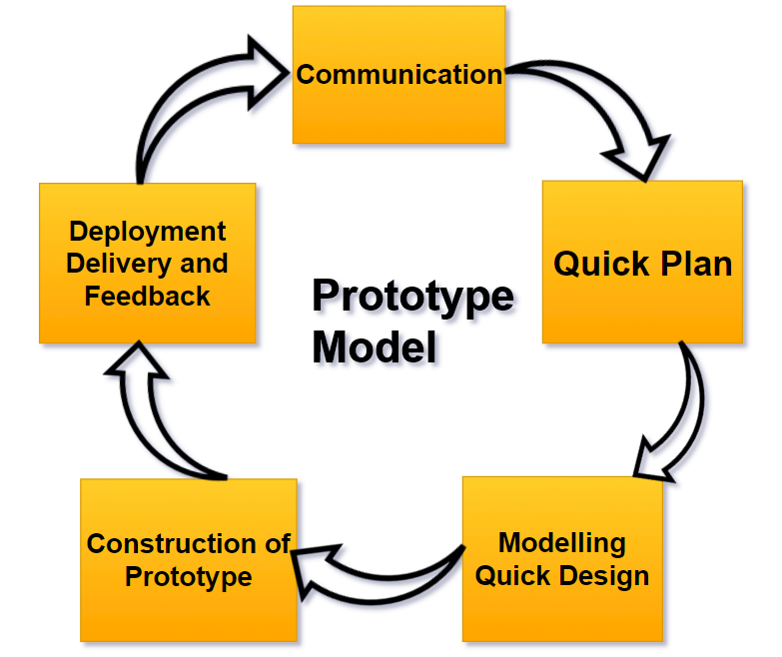

**Figure 12: Prototype Model**

The figure shows the prototype model processes. In this research, the process begins with communication with the targeted audience i.e. landlord, agent, and tenants. Requirements of the application were known through general observation of current situation and researcher’s personal experience. After knowing the requirements of the application, a quick plan was documented which is the application specifications. With the help of the existing chat application in the market, a quick design of the application was described. Once the requirements, design and specifications of the application was known, a prototype was constructed. As the application was built on Android, the application (.apk) file was circulated to the users, by which the feedback of the application was known. During the development of first few prototypes, there were many changes made to the application according to the feedback from the users. As full process was iterative, finally a final version of the application was decided and deployed.

## Requirements:

The main goal of this section is to define the functional and non-functional requirements of the Renter Solution chat application. For any software development, requirements analysis is very important. Without analyzing the requirements of the software, the application might be of no use to the targeted users. “*A requirement is a necessary attribute in a system, a statement that identifies a capability, characteristics, or quality factor of a system in order for it to have value and utility to a customer or user.*” Young (2004). In many industries, for a system development, insufficient time is spent on requirement related activities (Young, 2004). In this research implementation, requirement gathering was done at an early stage and data was analyzed through the process explained in Research Methodology chapter.

### Functional Requirements:

The functional requirements describe the functionalities of the software i.e. what an application should do (Young, 2004).

* **Signup:**

This requirement should ask every user with the option to signup by prompting name, username, gender, password, email, age, date of birth and mobile number. Once the user finishes signup, app should navigate to login page.

* **Login:**

This requirement will ask for Username and Password. If the user has already registered previously, the information of the user should be saved in the database in a server. If the username and password is incorrect, it should display “Invalid username or password”.

* **Type of User:**

The Renter Solution chat application should ask the user-type i.e. tenant, landlord, or agent before signup. According to the user-type, the signup form should display. For agent, without adding PSR (Property Services Regulatory) number, signup should not proceed. And for tenant, without specifying the current address (if renting for first time then should specify home country address), signup should not proceed. For landlord, the signup process is normal.

* **Logout:**

By clicking on the logout button, the user should be logged out and application should take user to login page.

* **Chat group display according to user:**

The chat application should display the chat groups on the Home screen according to the user if he/she is added in any group by the agent. Only agent can create chat groups in the application.

* **Chat:**

In this functional requirement, user should be able to send and receive messages on the group.

* **Search:**

This aspect of the requirement should allow every user in the application to search other user by their username who are registered.

* **Rate another user:**

This functionality is the most important function which makes this application different from other existing applications. This aspect will allow all the user to rate other users according to the behavior of landlord, agent, and tenants.

### Non-functional Requirements:

Non-functional requirements specify system properties which can be used to judge the system operation.

* **User-friendly:**

The application should be very simple to use but unique. The user should be able to navigate from one section to another section without any difficulty.

* **Availability:**

The application can be uploaded on the Google Play-Store, so that it can be available on every Android operating system device. As the number of android user today are much greater than the number of different operating systems.

* **Scalability:**

As the number of the users might increase because of the popularity, the server capacity can be upgraded which would be able to handle a greater number of users.

* **Performance:**

The experience of the user should be smooth throughout the app. This can be achieved by efficiency in chat message delivery, uploading a picture through camera.

* **Affordability:**

As the android smartphones are very cheap and available throughout Ireland, this can create great connectivity between the users. For example, if the tenants are staying in Dublin, and landlord is staying in Letterkenny which is in other part of Ireland, can still contact through this chat application.

### Efficiency

As the system requirements of the application is very less, i.e. 1 Gigabyte of RAM, 2 Gigabyte system memory and Android KitKat operating systems. In todays market, the mentioned system specification is in every smartphone, so the efficiency of the application is maintained.

## Artefact Design:

### Introduction:

This section of the research will show the design of the Renter Solution chat application through system architecture, class, use-case, and sequence diagrams.

### System Architecture:

An architecture of a system is like a blueprint of the system. According to Pressman (2010, pp. 243-245), the architecture of the system is a basic structure of the system which displays external properties of the components and relationship among them.

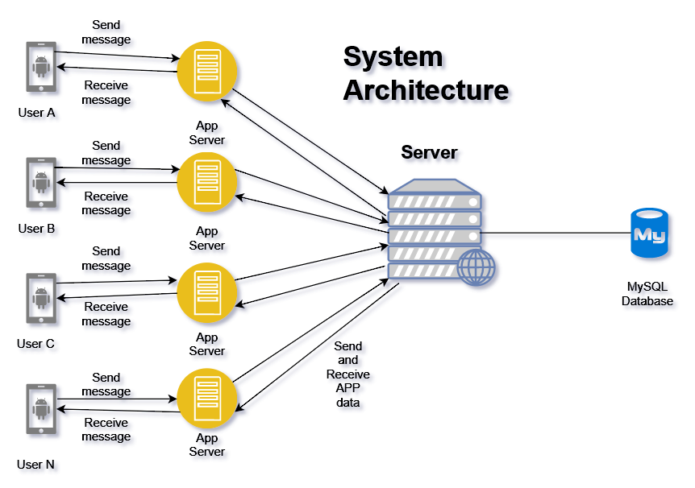

**Figure 13: Renter Solution System Architecture**

The above image illustrates the architecture of Renter Solution chat application which has several components in it. The user of the application must first login which will be validated from the MySQL database. XMPP (Extensible Messaging and Presence Protocol) is a set of technologies that are used for multi-party chats, instant messaging, light weight middleware and routing of XML data. It provides near real-time messages delivery for a chat interface to any other user over internet (XMPP, 2018). After the user has logged-in successfully, the web server will display the list of chat groups that a user is present in. For example, if User A sends a message on a chat where User B is also present, the message will pass through the App server and then XMPP. Then XMPP will send that message to all the App server i.e. users present in a group and then delivered to mobile application.

### Use-case Diagram:

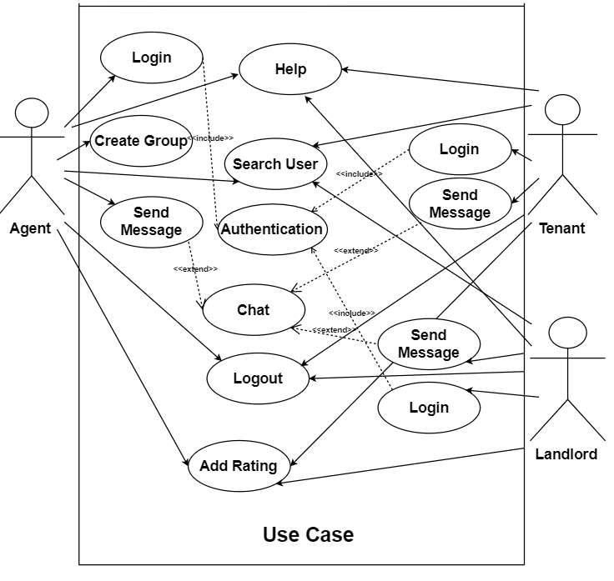A use-case diagram is used to show all the processes, actors, and relation between them in the software system (Dennis & Wixom, 2009, p. 517). Below is the Use-case diagram:

**Figure 14: Use-Case Diagram**

Figure 14 below shows the actors, processes (use cases), and relationship between them in Renter Solution app (Dennis & Wixom, 2009).

**User Story Summary:**

* There are three actors, an agent, landlord, and tenants.
* A chat group is made of many users.
* Only one actor (agent) can add other actors on the group.
* Once the actors are added on the group, they can send message.
* All the actors can search another actor.
* Every actor can rate another actor.
* Everyone can access to help process.

### Class Diagram:

The class diagram below shows all the classes and their association of the Renter Solution app which is represented graphically. For example, a user can view profile of all the users registered to the application.

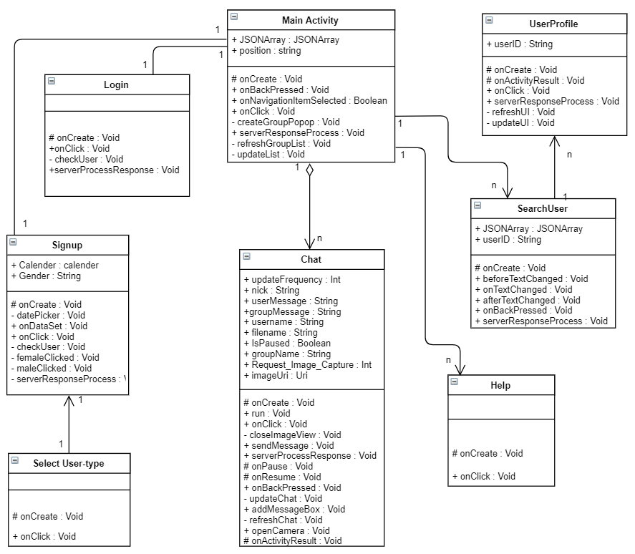

**Figure 15: Class Diagram**

### Sequence Diagram:

The sequence diagram below shows how objects interact with each other, and order of interaction (Dennis & Wixom, 2009). Below is the sequence diagram for Signup, Login, and Create group used in Renter Solution application.

**Signup process:**

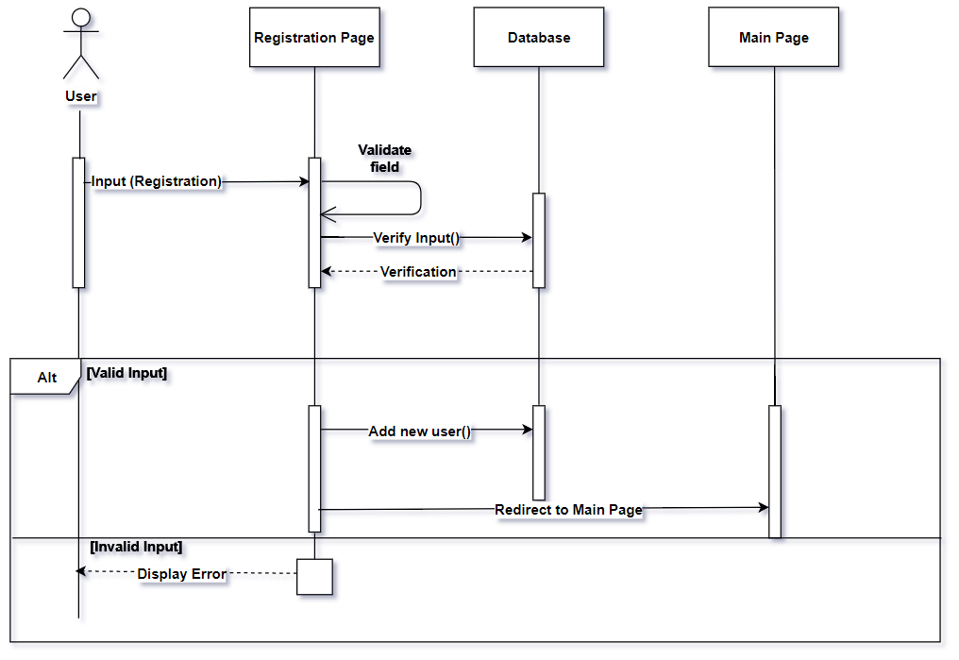

**Figure 16: Sequence Diagram for Signup**

The above diagram displays the sequence of the signup process. When the user enters the details, registration object will verify the fields and if they are correct, the user will be added to the database and redirect to main page. If the fields are not validated then, it will throw an error message.

**Login process:**

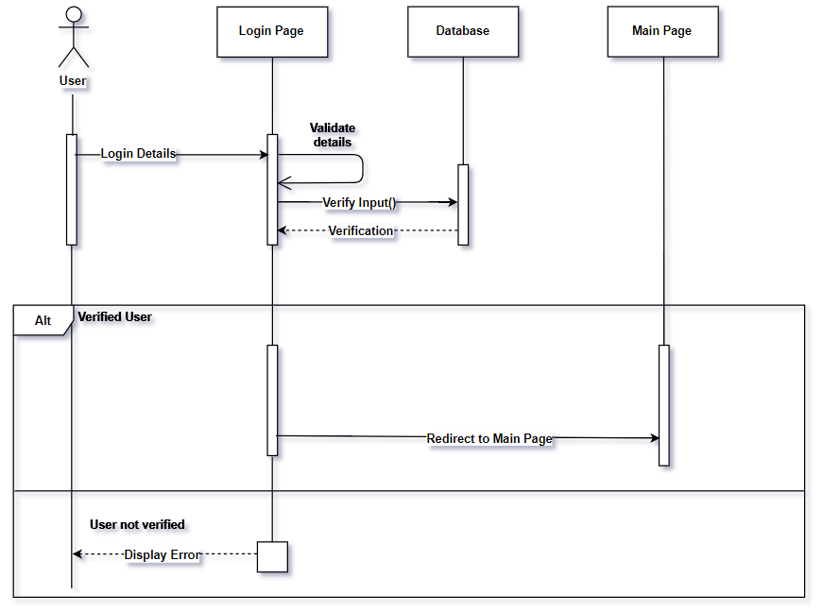

**Figure 17: Sequence Diagram for Login**

The login credentials are already stored in database. When user enters detail, it will verify in database, if it matches, user will be directed to main page else it will display error message to the user.

**Create group:**

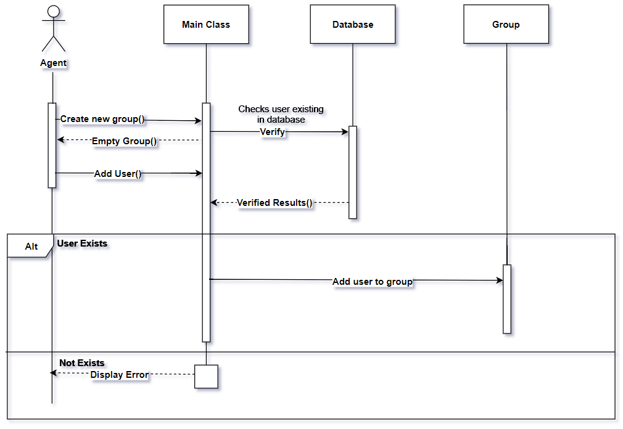

**Figure 18: Sequence Diagram for Create Group**

A group can only be created by agent, so when an agent creates a new group, one empty group will be created in which the agent will search the users to add on the group. When an agent searches a user, main class will verify in database and if results match, that user will be added on the group. If user is not present in database then, main class will throw error message to the agent.

### Renter Solution App Layout design:

For design of the application, XML has been used for designing the graphical user interface part of the application which is integrated with the Android Studio.

* **Login interface:**

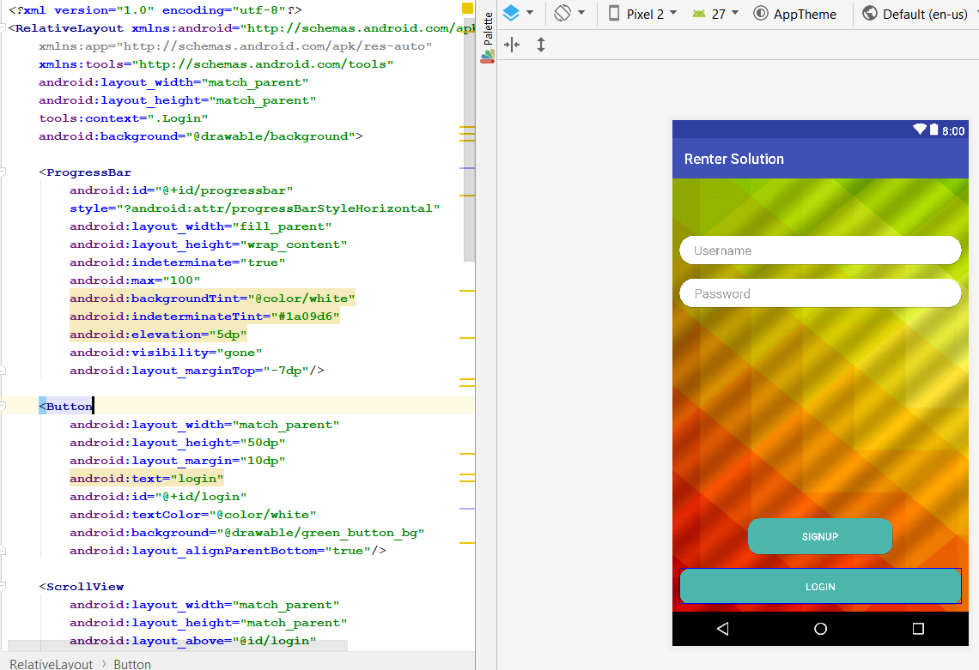

**Figure 19: Login Interface**

As the relative layout is very flexible layout to use in Android development which gives the flexibility to place component as per relative position (Developers, 2018). In the figure 19, two buttons and two edit text were created where buttons represent signup and login. The edit text will offer user to enter username and password. The interface of the login page is very simple and user-friendly to use. The main logic implementation was coded in **“Login.java”.**

* **Signup Interface:**

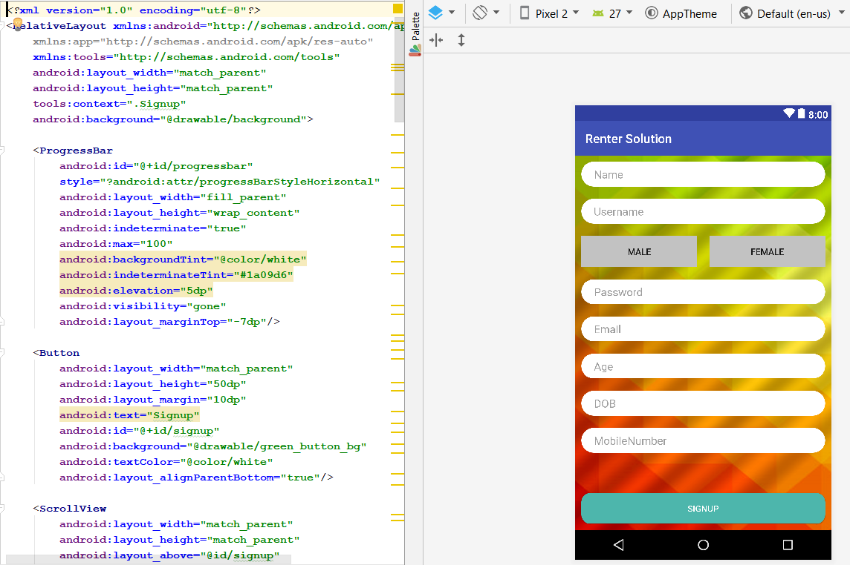

**Figure 20: Signup Interface**

For Signup interface, relative and linear layout was used to position various buttons and edit text fields. The signup interface has many fields, so scrollview is used for the users to scroll down for entering their details. The signup logic is coded in **“Signup.java”.**

* **Group Interface:**

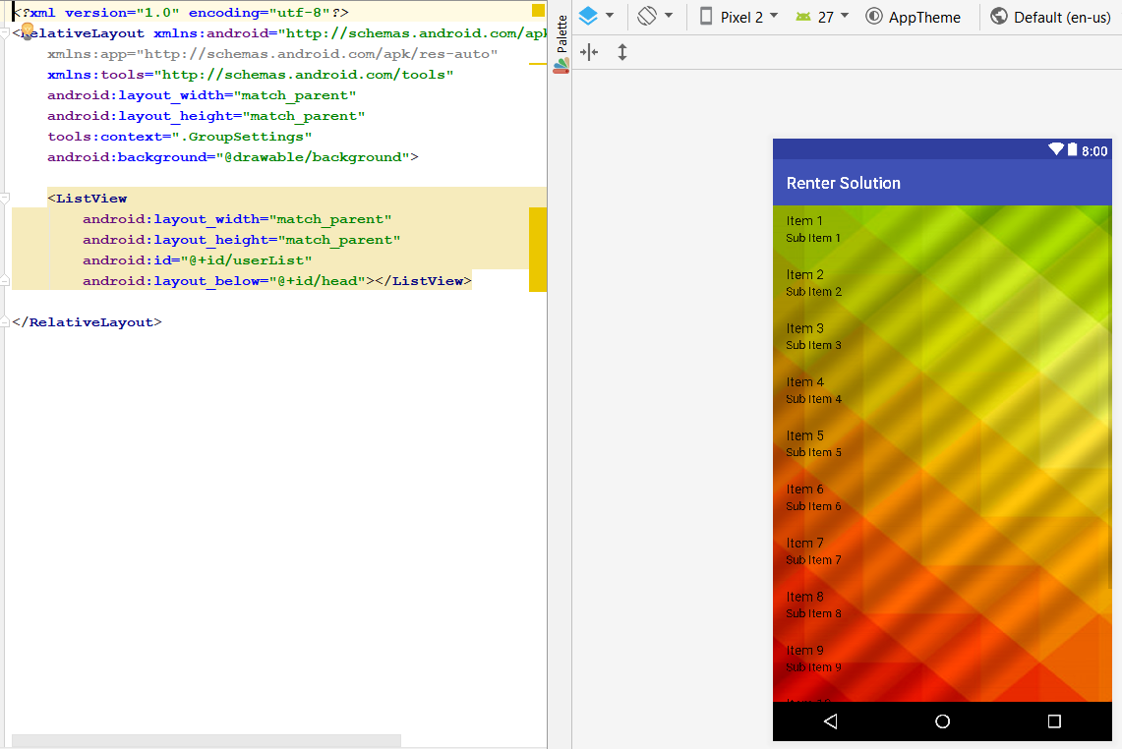

**Figure 21: Group Chat Display Interface**

The chat group interface contains relative layout in which, the groups will be displayed on the screen in list view to the user in which he/she is added. The main logic was coded in **“GroupSettings.java”.**

* **Help Interface:**

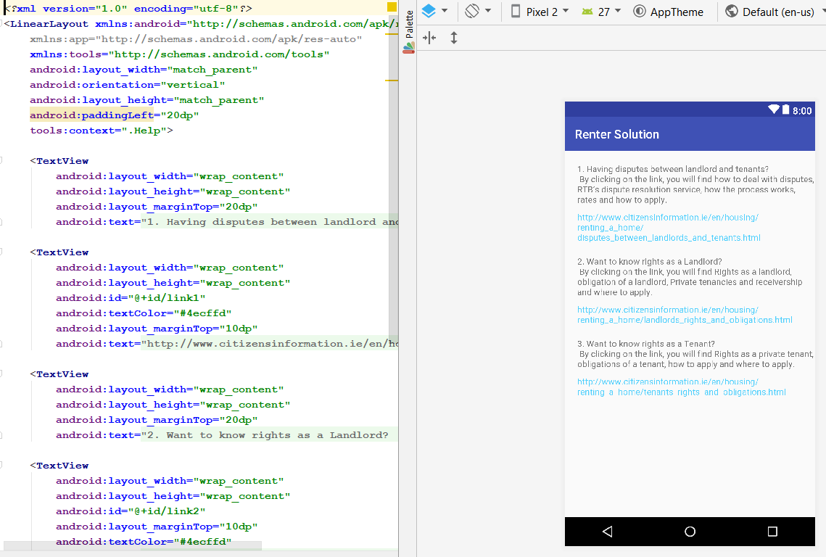

**Figure 22: Help Interface**

The layout used for help interface is linear. It displays the text followed with the website link for the users if they have any disputes etc. The logic was coded in **“Help.java”**.

* **Select User-type Interface:**

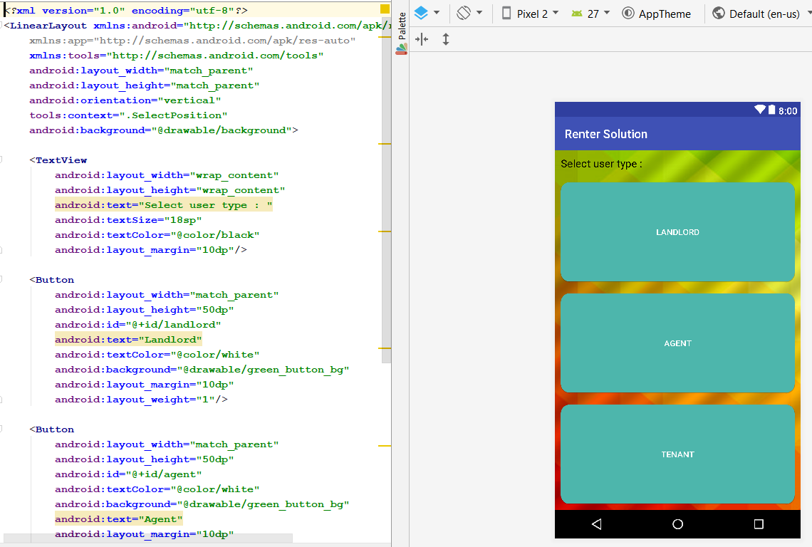

**Figure 23: User-type Selection Interface**

Foe the user-type interface, three buttons are used in a linear layout. New users will get this interface after pressing signup button. The logic was coded in **“SelectPosition.java”**.

* **User Profile Interface:**

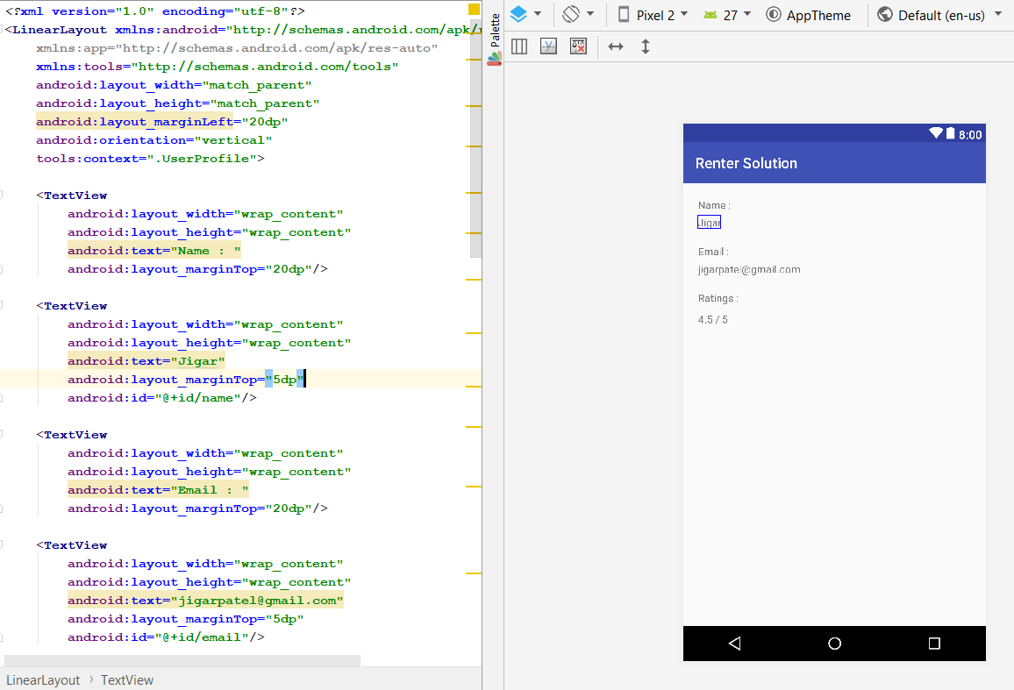

**Figure 24: User Profile Interface**

The interface of the user profile is kept very simple by displaying the name, email, and ratings of a user. The main logic was completed in **“UserProfile.java”.**



## Implementation of Artefact:

### Introduction:

This section gives a detailed description on implementation of prototype for rental solution chat application. This section is further divided into three subsections. First subsection will give a description of APIs that were developed and used in the development, second subsection will show the working of Renter Solution App.

### API:

All the APIs’ that were used in this application is developed by the researcher and no external or predefined API were used. All the APIs are created in PHP. Following are the list of the APIs’ developed and used:

* **addRatings.php**

After searching, with the help of POST method, rating is submitted to a user. The rating will be saved in the database.

* **Login.php**

When login form is submitted in POST method, the data is passed to the API and further it checks the data in the database. If username and password exist in the database, it will return required data such as user-position, name, and ID. If username and password doesn’t exist, it will return an error message.

* **Signup.php**

When signup form is submitted through POST method, the data is stored in the database using the signup API.

* **getUserList.php**

This API will be used to get the list of the users from the database which displays username and email.

* **getGroupList.php**

This API is used to retrieve all the groups in which user are enrolled. After login, user-id is passed to the API (getGroupList), then API checks the user id for each group in the database, and when it finds the group, it will store in array, and return to the main controller.

* **AddUserToGroup.php**

This API is used to add user to the group chat.

* **deleteUserFromGroup.php**

This API will delete a user from the group.

* **getUserDetails.php**

When a user enters a string in the search bar, this API contains a query which compares each string in the database that matches and returns the results which are Name, Email and Rating.

* **getData.php**

All the chat messages of the group are stored in text document with the time. When a user sends a text on the group, text document is appended where the chat messages of the group are stored, and the file is saved. This API will pull the text document and display on the user screen.

* **addGroup.php**

This API allows agent to create a new group that is saved in the database. Then the agent gets an option to add users such as tenant and landlord to the group.

* **GetGroupList.php**

This API will display the list of all the groups on the chat home screen in which the user is present.

### Working of Renter Solution Application:

* **Login Page:**

This is the first page (view) that user will get when he/she runs the application. In this page, the user will ask for username and password. After submitting username and password, it will verify entered credentials. The verification is done using login.php API. If the user is not registered with the App before, it will show signup option to the user. If user login credentials are correct, then it will show next view, otherwise it will show an error massage “Invalid Username or Password” in figure **25.**

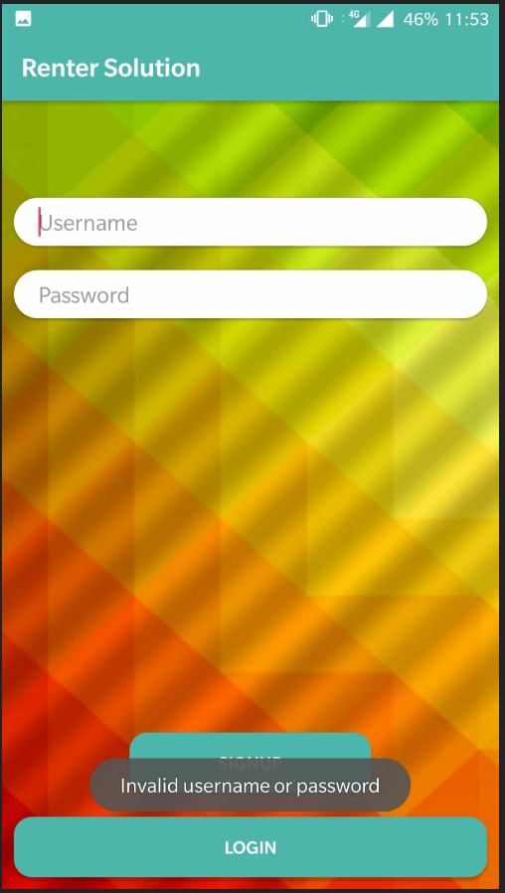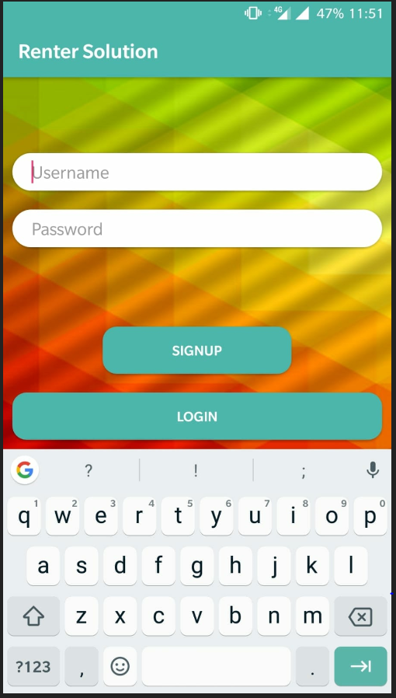

**Figure 25: Login Page view and incorrect credentials**

* **Signup Page**

If a user is new to application, that user must sign up. In signup class we are using signup.php API for storing the new user data into the server. Moreover, in signup view there are two mandatory fields without which the signup cannot be proceeded further. First one is “PSR License” number for agents and “current address” for tenants. Before signup user must select a category such as tenant, landlord, or agent. Figure **26 and 27** shows the image for signup view of all users:

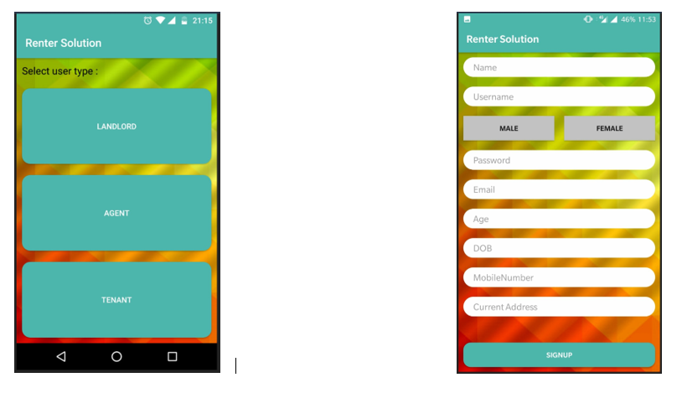

**Figure 26: Select User-Type and Signup for Tenant**

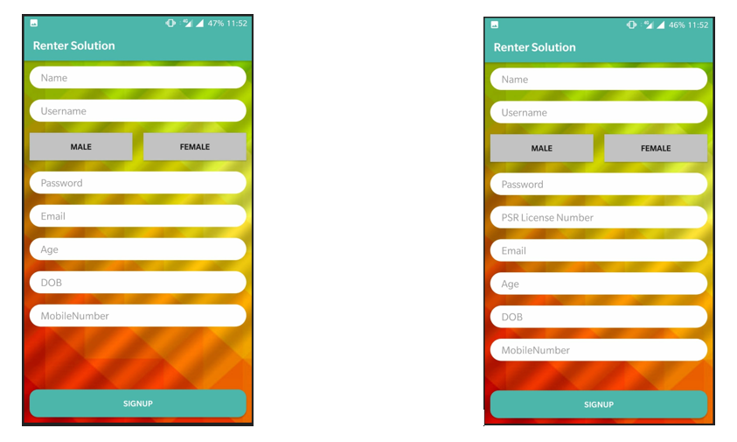

**Figure 27: Landlord Signup (Left) and Agent Signup (Right)**

* **Create Group:**

After successful registration, user needs to be enrolled in group for the actual use of application. The concept of group is to make interaction between all users i.e. agent, landlords and Tenants. For every house or apartment on rent, there should be a group in which all the tenants and landlords should be added by agent. Practically, agent and landlord can be added in many groups, but a tenant can only be present on one group. To add group in server, “addGroup.php” API is used. Figure **28** show the create group (add group) page and asking name of the new group.

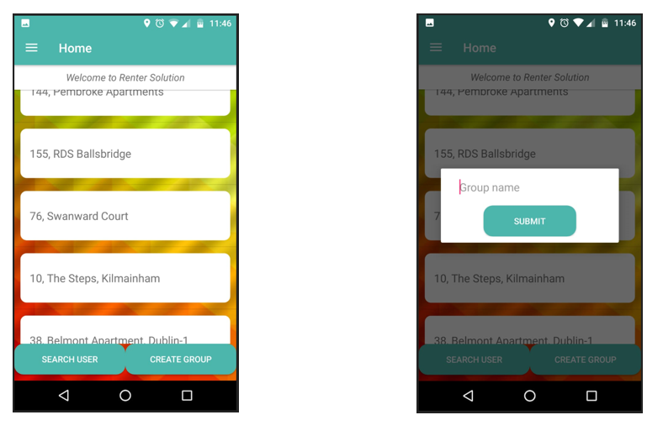

**Figure 28: Create group option only by Agent**

* **Main Page:**

After login, the control will pass to main page (Home) view. All the chat groups in which user is enrolled are displayed on the main page. User can select any chat group and he/she can write any message there. Figure **29** show the chat list on main page of all the users. A tenant can only be in one chat group as seen in figure 29 on right. Agent and landlord can be present on several apartment groups.

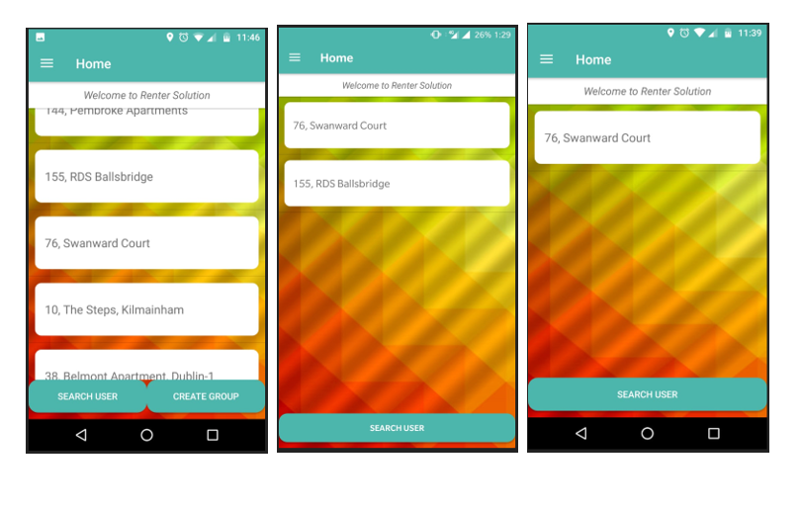

**Figure 29: Main page of Agent (Left), Landlord (Middle) and Tenant (Right)**

* **Chat:**

In chat, two APIs are used which are putData, getData, and putImage. User can send, receive text messages, and send images on the group. Figure **30** shows the chat screen and communication between the user and an option to send image through camera.

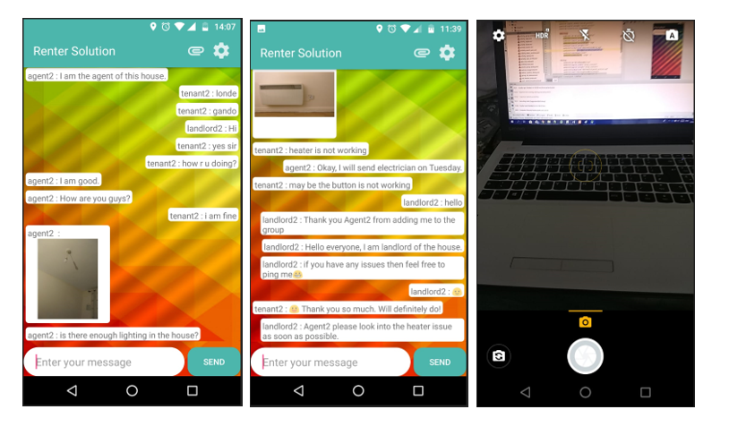

**Figure 30: Communication between landlord, agent, and tenant**

* **Get user details and Rating the user:**

This application provides important functionality to search and give ratings to any user in a group. To search and add rating to a user in the database, “addRating” and “getUserDetails” APIs are used. Figure **31** shows searching and rating view.

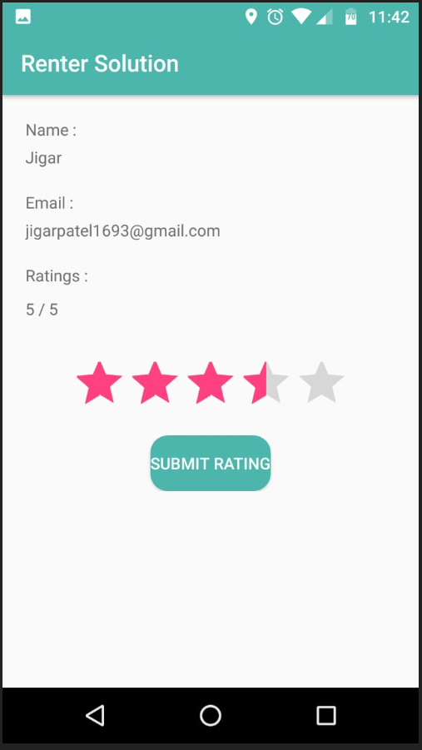

**Figure 31: Search and submit Rating to the user**

* **Search, Add, and Remove:**

Every user present in the group can search, add, and remove users from the group. To search user in the database, getUserList API is used. Moreover, to add user in the group “addUser” API is used and to remove user from the group “deleteUserfromGroup” is used. Figure – shows all functionality.

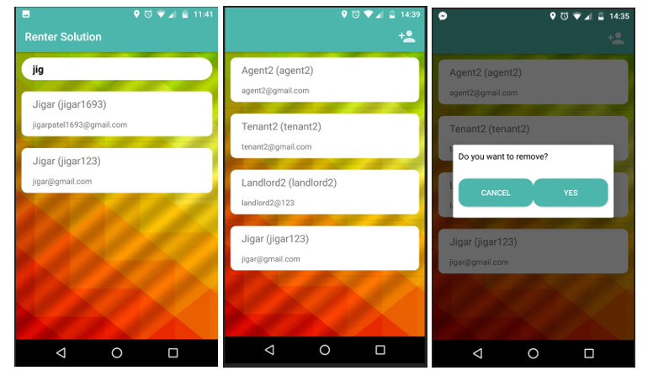

**Figure 32: Search User (Left), Add User (Middle), Remove User (Right)**

## Limitation of Implementation:

* Due to the time limitation, post feedback, voice and video calls, profile updating, and message encryption feature was not developed. This can get updated in second version of the app.

# Chapter 5: Data Analysis and Findings

## Introduction:

This chapter will display the outcomes of the survey that are related to the research. Data analysis is the study of the data collected through primary and secondary data collection sources. The secondary source of the data collected is already explained in Chapter 2 i.e. literature review, which shows existing theories related to this study. The primary data collection sources are Questionnaire and Audio interviews taken from targeted audience. In this research, type of research method used to collect primary data is Qualitative. This chapter is further divided into two sections, first will be survey results, and second will be the interpreted results of the respondents related to this study.

## Survey Results:

**Age Segmentation of Respondent:**

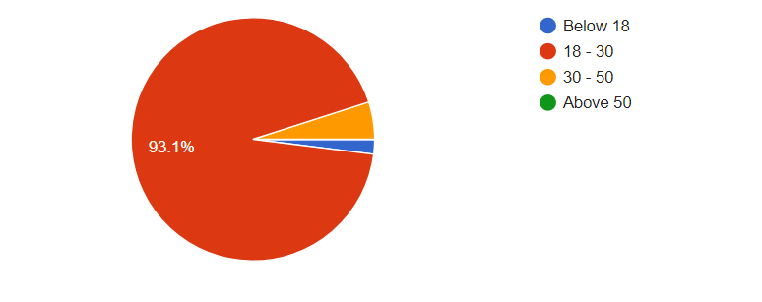According to the survey results, 94 respondents representing 93.1% of total 101 respondents belongs to the age between 18 to 30 years, five respondents representing 5% of respondent belongs to the age between 30 to 50, while only two respondents representing 1.9% of total respondent belongs to age below 18 years and none of the respondent is above the age of 50.

**Gender of respondents:**

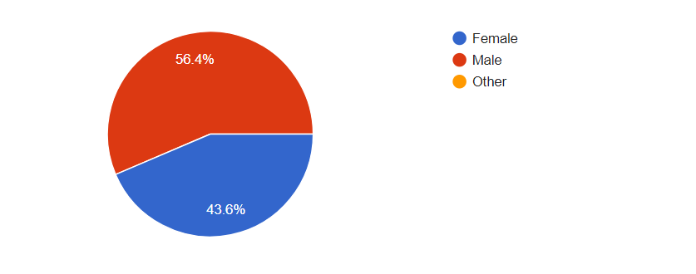Results shows that majority of the respondents representing 56.4% of total respondents are male, while remaining are female and none of the respondents belongs to other group.

**Type of user:**

**A close up of a logo

Description generated with high confidence**As per the survey results, all respondent belongs to tenant (International student), while only one respondent is Agent and none of the respondent is Landlord.

**City of residence of tenants:**

**A screenshot of a cell phone

Description generated with very high confidence**As per the survey results 23 respondents representing 70.3% of total respondents belong to Dublin, while 8 respondents representing 7.9% of total respondents belongs to bray and other belongs to different cities of Ireland.

**How long have you been living in Ireland?**

**A close up of a logo

Description generated with high confidence**

As per survey results 60 respondents represents 62.4% of total respondents who are living in Ireland for 6 to 12 months, 15 respondents representing 14.9% of total respondents are living in Ireland for 0 to 6 months and very few of them are living for more than a year.

**Type of Operating System used by targeted users:**

**A screenshot of a cell phone

Description generated with very high confidence**When asked about the operating system from the respondent, majority of them representing 77.2% of total were using android smartphone users, while 30.7% of respondents were using Apple (iOS) and very few them were using other operating systems.

**Have you ever faced any issue with your Landlord and Agent during tenancy period?**

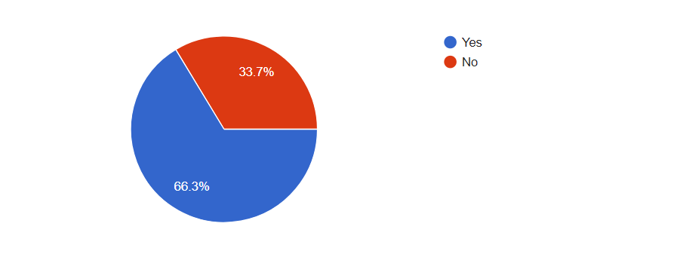

When asked about the problems they ever face, majority of the respondents representing 66.3% of total respondents said “YES”, while others said “NO”.

**Who manages your house during your tenancy period?**

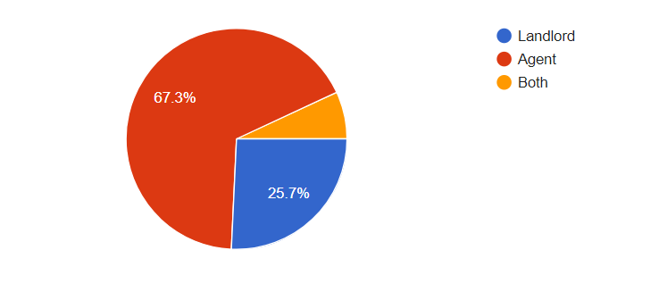As per survey results, most of the rented properties (67.3%) are managed by Agents, 25.7% of properties are managed by landlords and very few properties are managed by both.

**If your rented house needs any maintenance work done, then how many days does it take for an agent to get it fixed?**

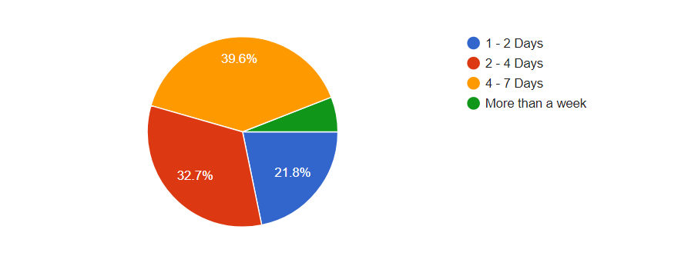

According to survey results, 40 respondents representing 39.6% of total respondents said that it takes 4 to 7 days to get work done, while 33 respondents representing 32.7% of total respondents said that it takes 2 to 4 to get work done, 22 respondents representing 21.8% of total respondents said that it takes 1 to 2 days to get work done and very few said it takes more than one week.

**Assume that you are in a situation where you have an issue with your agent and landlord which is unable to resolve mutually, then what would be your next step?**

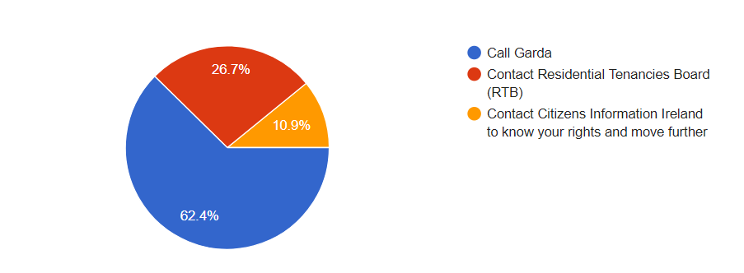When asked from the tenants about the next step they would take when they have an issue with landlord or agent, 63 tenants representing 100 tenants said they would like to call garda, 27 tenants representing 100 tenants said they would like RTB and some said they would like to contact citizen information Ireland to know their rights.

**As a tenant, do you feel that there is any communication gap with your agent and landlord?**

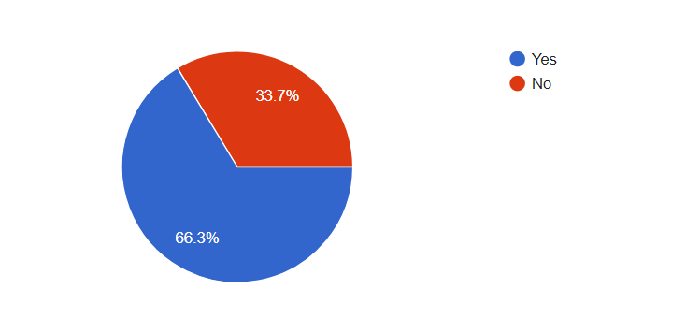 According to survey results, 67 respondents representing 66.3% of total respondents said “YES” and 34 respondents representing 33.7% of respondents said “NO”.

**Did you ever come across any tenant, agent, and landlord Messaging APP?**

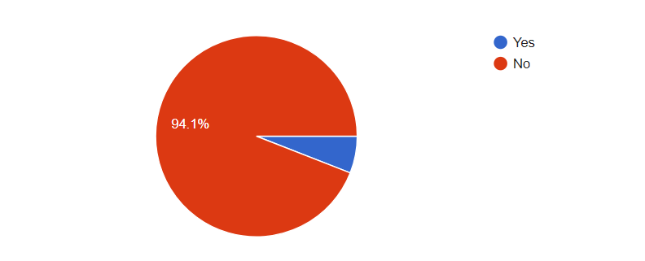As per survey result, 95 respondents representing 94.1% of total respondents said “NO”, while some of them said yes.

**What if an APP is designed and implemented where only tenants, agent and landlord can use the chat feature to discuss any problems and seek permission from the landlord for repair or maintenance etc. and to rate and post feedback on each other’s profile and have all Disputes and Rights related details in the APP itself. Will it be helpful?**

A close up of a logo

Description generated with high confidenceAs per survey results majority of the respondents said “YES” representing 86.1%, while 11.9% said “Maybe” and very few said “NO”.

**Do you think using this APP will reduce the communication gap between tenants, agent and landlord?**

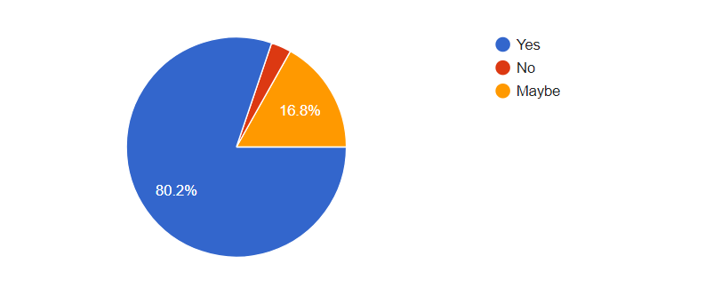

As per survey results, 81 respondents representing 80.2% of the respondents said “YES”, 17 respondents representing 16.8% of the said “Maybe”, while very few said “NO”.

**Do you think the rating and posting feedback feature on each other’s profile (tenant, landlord and agent) will eliminate the need of Reference Letter for a tenant searching a new house?**

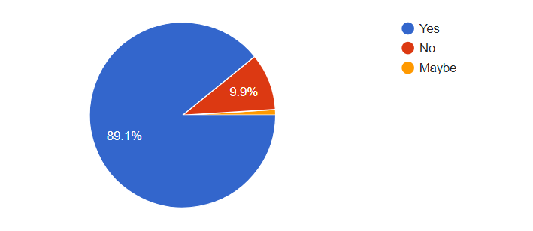

As per the survey results 90 respondents representing 89.1% of total respondents said “YES”, 10 respondents representing 9.9% of total respondent said “NO” and very few said “Maybe”.

**How helpful will this APP be in future on a scale of 5?**

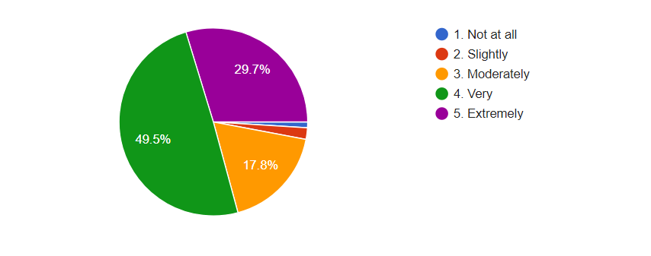

As per the answer, 50 respondents representing 49.5% of total respondents said, “very helpful”, 30 respondents representing 29.7% of total respondents said “extremely”, 18 respondents representing 17.8% of total respondents said “Moderately” and very few of them said “slightly” and “not at all”.

## Interpretation of Results:

### Choice of Android:

According to the Statcounter (2017), the use of Android phones in Ireland till December 2016 was 58.4% as compared to the major operating systems iOS and other OS as shown in the figure 33 below. The percentage of those users will keep increasing as many phone companies use Android OS on their devices.

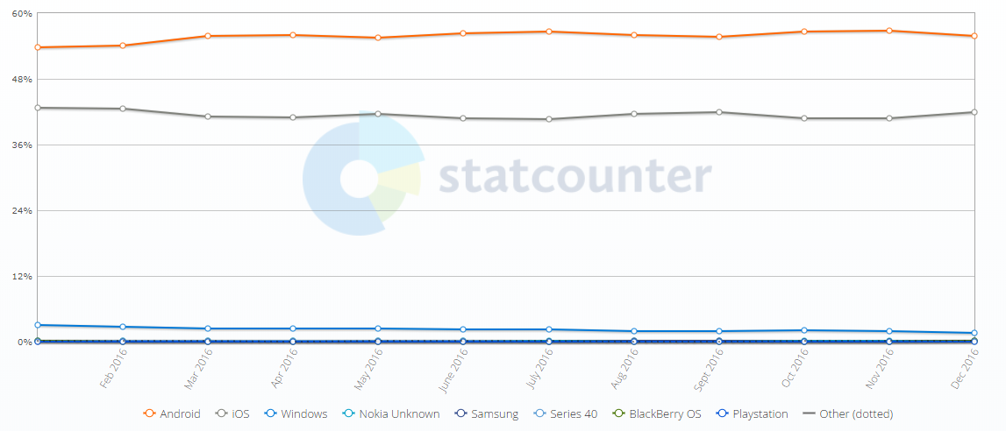

**Figure 33: Users of Android Operating System** (Statcounter, 2017)

Also, according to the survey results, a greater number of the targeted audience uses Android OS which is cheap and affordable, therefore the choice of developing software on Android platform.

### Issues between tenants, agent, landlord:

As per the results of the survey, greater number of respondents have faced issues with agents which are not been solved mutually because of the communication gap. The real-world scenario of tenants depicts that the agents never replies to tenant’s query where they are expected to respond to the complaints by tenants. As many of the respondents share their experience, and most common issue are, agents being arrogant, standard maintenance of the apartment is not maintained, household appliances not working and not answering the call. This clearly shows lack of communication between tenants, agent, and landlord. According to Citizens (2017), the agent should maintain the minimum standard regulation of the apartment before letting an apartment to rent.

1. **Awareness of rights:**

According to the outcomes of the survey, lot of respondents are not aware about their rights during tenancy period. When asked about actions taken by them towards any issue with agent or landlord, most of the respondents have not taken any action. And others who have acted to the situation, have contacted to Garda for help where they have faced disappointment. For this, the research has added “Help” section which includes the website links have details about dispute resolution and rights of tenants and landlords.

### Communication gap factor:

The outcome of the survey results clearly explains that there is a big communication gap between tenants, agent, and landlords. Out of the total responses, 67 respondents say that there is a communication bridge. When asked for the reason, most of the respondents don’t even know who the owner of the house is. Even if tenants know the landlord, they have never seen or spoken with the landlord during their tenancy period. Some of the responses state that, agent and landlord are arrogant and asks tenants to leave the house without any eviction notice. To build this communication, Renter Solution will play vital role and make the situation transparent and avoid any conflicts between them.

### Audio Interview:

The audio interview was conducted with the consent of the participant Mr. Noel Diamond who is an owner of 36 houses in Ireland and manages a total of 62 apartments through agents under him. As an owner of houses, Mr. Noel Diamond has also represented on behalf of the agents. At start of the interview, researcher explained about the study of this research and demonstrated the working of Renter Solution app. The conclusion of the interview is that, there is communication gap between all of them and in some cases, there are disputes which were dragged to RTB for resolution. An agent who is a middleman for tenants and landlord, always suffers in most of the situations and ultimately tenants will face consequences. In the end, researcher asked for the feedback of the demonstrated artefact. The feedback of the artefact was very positive, and Mr. Diamond also suggested for new feature that can be added in future. This motivated the researcher to take the artefact on a large scale and provide a small help in targeted user’s world.

(The audio clip is submitted within the zip file and uploaded on GitHub.)

# Chapter 6: Research Discussion

## Discussion:

This chapter of the research is all about discussing and introspecting the objectives and the requirements that were elaborated in chapter 1 and evaluate how many of them were achieved. In this chapter, the researcher focuses on discussing the major phases of research development and also drafted the recommendation concerned with the development of the project. The main reason for this research is that, to find out an easy and reliable way to fill out communication gap between tenants, landlord, and agent. The objective of this research is to develop a chat application on Android platform where tenant, landlord, and agent can communicate with each other without any hesitation. The purpose of this research was achieved by developing an application that satisfied all the research objective.

There were many methods thoroughly reviewed and investigated during this research and many of them stood out to provide the solution to the problem stated. During this research phase, two methods stood out to be perfect for the study, they are “Questionnaire” and “Audio Interview”. Using those methods, researcher got to know in-depth problems and it played vital role in this study because it provided good foundation to the solution of the problem. In MSc Information Systems with Computing module, researcher never came across the concept of interviews with the stakeholders, but it was truly wonderful and amazing experience to interview Mr. Noel Diamond who owns many properties in different parts of Ireland and manages properties as an agent. Moreover, in reviewing the previous work done specified in Chapter 2, the researcher took a step forward and read “Landlord and Tenant Law” book which helped to gain information about tenancy laws.

The main aim and requirements of this research were described in the chapter 1. This research answers and meets the requirements by developing chat application. An application which is focused for specific users with features like rating another user, it will provide all the information under “Help” section which has website links to RTB resolution service, rights & obligations of users, and check any user details by entering username in the search bar. According to the researcher, this study has met the requirements of the research question and will reduce the communication gap between tenants, landlord, and tenants.

## **Recommendation**:

In the current market, there is no chat application developed for tenancy to the extent of researcher’s knowledge. The recommendation that a researcher would give is for Landlords and tenants.

* **Landlord:**

While registering into Renter Solution app, landlord will have to select as **Agent user-type** if there is no agent in between for the process to let a property on rent. The reason to recommend Landlord is that, only agents can create chat home groups in this application.

* **Tenants:**

While registration of tenants, there is a mandatory field that tenant must answer before proceeding. The field is “Current Address” of a tenant. If a tenant is new to the country, then he/she must specify address in home country.

# Chapter 7

## Conclusion:

The concept of this study is to reduce communication gap, resolve disputes, and propagate smooth communication by bridging the communication gap through the means of Renter Solution Chat Application based on Android platform. During the study of this thesis, the concept of bridging communication gap for the current situation in real-world scenario by developing a software was achieved. During the development stages of the application, there were major changes done to the artefact and design which would help the users to understand the application and meet the requirements of the research question specified.

According to Residential Tenancies Board (RTB), there are lot of cases filed regarding disputes between landlord, agent, and tenants which is mainly because of lack of communication. Most of the cases would get solved by a mediation service which is provided by RTB. Basically, Mediation helps the actors involved in the process to communicate within themselves and find a solution for specified problem. This problem can get solved before involving any Mediation from RTB by communicating within them. Also, the awareness level of tenants as compared to landlord and agent is very low which results the tenants to suffer until the contract is over. These are one of few reasons to research and focus on three types of actors and relationship among them in Ireland and provide with a solution.

Finally, this research work was able to identify that, with number of chat applications available on the internet today, choice of specific users, rather than focusing on the other population, is justifiable. A new way to communicate, acting as a mediator among the specific users, implementation of a well framed mobile chat application for targeted users, may eventually lead to improve the understanding and therefore reducing the communication gap and disputes between tenants, landlord, and agents. To conclude, Renter Solution Chat Application will be an easy and efficient way to convey the message to the correct person within time. Hence, the researcher concludes that aim and objective of this research is achieved based on the above stated facts.

## Future Scope:

The developed artefact of this research can be optimized in future that will help the targeted users. Advancement that can be done are:

* End-to-End message encryption can be used to encrypt messages.
* For authenticating the users, SMS API or OAuth (open authorization) can be added through which users can be verified by OTP, Gmail, or Facebook accounts.
* Options to send audio, video, location, document, calling, and contact can be added.
* Database and server can be upgraded to handle high number of users.
* Updating the profile can be added in future.
* The app can be further implemented on different platforms.
* The registration process of a new user can be done through RTB, where tenants will directly get registered with RTB.
* Another feature is, once agent adds a tenant in a house group, that tenant should get registered for respective apartment in RTB.
* Can also add a complaint section and rate the urgency on a scale of 5 or 10. This could get work done much easier.

## Self-Reflection:

This section of the study reflects the learning and outcomes that researcher has gained through the course of MSc Information Systems. During the development stages of the artefact and design for this research, researcher has used the concepts of Web and Mobile Development as a base for artefact design and development. Also, the researcher has realized practical use and concepts of the Software Engineering which acts as a backbone of the software applications. The researcher has used Database for the artefact which stored essential information of the App users. The Database Management and Systems module has provided in-depth knowledge of the database, through which the researcher was able to implement Database system for research artefact. Furthermore, the researcher has gained knowledge from the overall module of MSc Information Systems with Computing.

Moreover, the researcher was passionate to implement the research artefact to help the current situation between the landlord, tenants, and agent. Personal experience of the researcher also played an important role. With the motive to solve current issue, the researcher took a step further to learn keen concepts of Android programming for the development of research artefact. To better understand the current situation in real world, research was done by the means of questionnaire.

Going further, the main intention of the MSc Information Systems module was to prepare the students with technical and analytical skills which is required to acquire a prime job position in software industry. By the means of this study, researcher has developed interest in Android Development and chosen to progress and develop career in that field. Finally, the researcher has gained experience and confidence by research and helped to motivate for future job.

# References

Allo, G., 2018. *Google Allo.* [Online]   
Available at: https://allo.google.com/  
[Accessed 16 August 2018].

Baneham, K., 2015. *Introduction to Residential Tenancies (Amendment) Act 2015 and The Impact on Housing Associations.* [Online]   
Available at: https://www.icsh.ie/sites/default/files/introduction_to_residential_tenancies_amendment_act_2015.pdf  
[Accessed 5 August 2018].

Board, R. T., 2018. *Residential Tenancies Board.* [Online]   
Available at: https://www.rtb.ie/residential-tenancies-(amendment)-act-2015  
[Accessed 4 August 2018].

Citizens, I., 2017. *Citizens Information.* [Online]   
Available at: http://www.citizensinformation.ie/en/housing/renting_a_home/private_residential_tenancies_board.html  
[Accessed 31 July 2018].

Citizens, I., 2017. *Citizens Information.* [Online]   
Available at: http://www.citizensinformation.ie/en/housing/renting_a_home/repairs_maintenance_and_minimum_physical_standards.html  
[Accessed 20 August 2018].

Citizens, I., 2018. *Citizens Information.* [Online]   
Available at: http://www.citizensinformation.ie/en/housing/renting_a_home/disputes_between_landlords_and_tenants.html  
[Accessed 28 July 2018].

Creswell, J. S., 2009. *Research Design.* 3 ed. Los Angeles, London, New Delhi, Singapore: Sage Publications, Inc..

Dennis, A. & Wixom, B. H. W., 2009. *System Analysis and Design.* 5th ed. USA: John Wiley and Sons, Inc..

Department of Housing, P. a. L. G., 2016. *Department of Housing, Planning and Local Government.* [Online]   
Available at: https://www.housing.gov.ie/housing/social-housing/voluntary-and-cooperative-housing/approved-housing-bodies-ahbs  
[Accessed 1 August 2018].

Developers, A., 2018. *Android Developers.* [Online]   
Available at: https://developer.android.com/guide/topics/ui/layout/relative  
[Accessed 21 August 2018].

Gabry, O. E., 2017. *Medium.* [Online]   
Available at: https://medium.com/omarelgabrys-blog/software-engineering-software-process-and-software-process-models-part-2-4a9d06213fdc  
[Accessed 19 August 2018].

Ghare, N., Rahurkar, P. K., Latkar, M. & Bote, A. S., 2015. Bluetooth Chat Application: Bluez. *International Journal of Engineering and Computer Science,* 4(3), pp. 10674-10679.

Halpin, H., 2018. *thejournal.ie.* [Online]   
Available at: http://www.thejournal.ie/rent-landlord-eviction-orders-3794785-Jan2018/  
[Accessed 1 August 2018].

Holden, M. T. & Lynch, P., 2004. Choosing the Appropriate Methodology: Understanding Research Philosophy. *The Marketing Review,* 4(4), pp. 379-409.

Information, C., 2018. *Citizens Information.* [Online]   
Available at: http://www.citizensinformation.ie/en/housing/renting_a_home/disputes_between_landlords_and_tenants.html  
[Accessed 26 July 2018].

Istead, K., 2017. *Student World Online.* [Online]   
Available at: http://www.studentworldonline.com/article/ireland%E2%80%99s-rise-as-a-destination-for-international-students/982/  
[Accessed 28 July 2018].

Lyons, R., 2017. *Independent.ie.* [Online]   
Available at: https://www.independent.ie/life/home-garden/what-hope-for-students-amid-our-housing-crisis-36137819.html  
[Accessed 28 July 2018].

Mahajan, N. et al., 2014. Design of Chatting Application Based on Android Bluetooth. *International Journal of Computer Science and Mobile Computing,* 3(3), pp. 712-717.

McDonald, N., 2018. *We Are Social.* [Online]   
Available at: https://wearesocial.com/us/blog/2018/01/global-digital-report-2018  
[Accessed 15 August 2018].

Mehrotra, P., Pradhan, T. & Jain, P., 2014. Instant Messaging Service on Android Smartphones and Personal Computers. *Internation Journal of Information and Computation Technology,* 4(3), pp. 265-272.

Miller, C., 2016. *Inferse.* [Online]   
Available at: https://www.inferse.com/42092/google-announces-new-allo-duo-apps-renewed-push-personal-messaging-segment/  
[Accessed 16 August 2018].

O'Brien, C., 2017. *Irish Times.* [Online]   
Available at: https://www.irishtimes.com/news/education/brexit-sparks-surge-in-foreign-applicants-for-irish-universities-1.3173982  
[Accessed 28 July 2018].

Phoneia, 2018. *Phoneia: Technology and Entertainment.* [Online]   
Available at: https://phoneia.com/whatsapp-for-android-is-redesigned-with-material-design/  
[Accessed 16 August 2018].

Point, T., 2018. *Tutorials Point.* [Online]   
Available at: https://www.tutorialspoint.com/sdlc/sdlc_software_prototyping.htm  
[Accessed 20 August 2018].

Pressman, R. S., 2010. Software Engineering: A Practitioner's Approach. In: R. S. Pressman, ed. *Software Engineering: A Practitioner's Approach.* 7th ed. Boston: Mc Graw Hill Higher Education, pp. 42-44.

Rogers, J., 2018. *myhome.ie.* [Online]   
Available at: http://blog.myhome.ie/2012/07/13/8-common-home-inspection-problem-areas/  
[Accessed 28 July 2018].

RTB, 2018. *Residential Tenancies Board.* [Online]   
Available at: https://onestopshop.rtb.ie/dispute-resolution-old/third-party-dispute-resolution-services  
[Accessed 4 August 2018].

Rubio, 2015. *Digital Chalkboard.* [Online]   
Available at: https://www.mydigitalchalkboard.org/portal/default/Content/Viewer/Content?action=2&scId=514976&sciId=18985  
[Accessed 19 August 2018].

Ryan, P., 2016. *Independent.ie.* [Online]   
Available at: https://www.independent.ie/business/personal-finance/property-mortgages/surge-in-complaints-against-landlords-hiking-rents-34633827.html  
[Accessed 31 July 2018].

Sonwane, S. et al., 2017. Doctor Patient Data Sharing Using Android Chat Application. *International Journal of Recent Trends in Engineering and Research,* 3(4), pp. 170-174.

Statcounter, 2017. *Statcounter: Global Stats.* [Online]   
Available at: http://gs.statcounter.com/os-market-share/mobile/ireland/2016  
[Accessed 22 August 2018].

Statista, 2016. *Statista: The Statistics Portal.* [Online]   
Available at: https://www.statista.com/statistics/330695/number-of-smartphone-users-worldwide/  
[Accessed 15 August 2018].

Verma, C. P., Singh, S. P. & Kumawat, B., 2013. Intranet Based Messaging Service on Android Smartphones and Tablets. *International Journal of Advanced Research in Computer Science and Software Engineering,* 3(7), pp. 1030-1032.

Viber, 2018. *Viber.* [Online]   
Available at: https://www.viber.com/  
[Accessed 16 August 2018].

WhatsApp, 2018. *WhatsApp.* [Online]   
Available at: https://www.whatsapp.com/features/  
[Accessed 16 August 2018].

Whetsell, T. & Airoldi, D. M., 2018. *Brick Underground2018.* [Online]   
Available at: https://www.brickunderground.com/blog/2013/06/renters_beware_11_things_to_look_out_for_in_that_lease  
[Accessed 28 July 2018].

Wylie, J., 2014. Residential Tenancies Act 2004. In: G. V. Patterson, ed. *Landlord and Tenant Law.* Ireland: Bloomsbury Professional, pp. 551-553.

Xcommunity, A., 2017. *Android Xcommunity.* [Online]   
Available at: http://androiddeveloper.galileo.edu/2017/09/25/advantages-using-android-official-tools/  
[Accessed 18 August 2018].

XMPP, 2018. *XMPP.* [Online]   
Available at: https://xmpp.org/about/technology-overview.html  
[Accessed 21 August 2018].

Yasser, R. Y. et al., 2017. *Future University in Egypt.* [Online]   
Available at: http://dspace.fue.edu.eg:8080/xmlui/handle/123456789/26  
[Accessed 16 August 2018].

Young, R. R., 2004. *The Requirements Engineering Handlook.* 1st ed. Boston, London: Artech House INC..

# Appendices:

## Appendix A: Definition of Terms

RTB – Residential Tenancies Board

UCC – University College Cork

TCD – Trinity College Dublin

UCD – University College Dublin

OS – Operating System

E2EE – End-to-End Encryption

PSR – Property Services Regulatory

LAN – Local Area Network

RFCOMM – Radio Frequency Communication

MAC – Memory Access Control

TCP – Transmission Control Protocol

BLE – BT Low Energy

P2P – Peer 2 peer

XMPP – Extensible Messaging and Presence Protocol

PHP – Personal Home Page

XML – Extensible Markup Language

IDE – Integrated Development Environment

## Appendix B: Questionnaire

**1. What is your name?**

**2. What is your age?**

Below 18

18 – 30

30 – 50

Above 50

**3. What is your Gender?**

Male

Female

**4. Which country are you from?**

**5. Who are you?**

An International Student (Renter)

Landlord

Agent

**6. If you are an international student then, which University are you studying in?**

**7. Where are you currently residing? (E.g. Dublin, Cork etc.)**

**8. How long have you been living in Ireland?**

0 - 6 Months

6 - 12 Months

1 - 2 Years

2 - 3 Years

More than 3 Years

**9. Which Smartphone are you using?**

Apple

Android

Windows

Blackberry

Other

**10. How long did it take to find accommodation after coming to Ireland?**

**11. Have you ever faced any issue with your Landlord and Agent during tenancy period?**

Yes

No

**12. If your above answer is yes then, what issue have you faced?**

**13. Who manages your house during your tenancy period?**

Landlord

Agent

Both

**14. If you have any issue within your house, then who is the first point of contact?**

Landlord

Agent

**15. If your rented house needs any maintenance work done then, how many days does it take for an agent to get it fixed?**

1 – 2 Days

2 – 4 Days

4 – 7 Days

More than a week

**16. What action have you taken if you ever had any issue with your agent or landlord?**

**17. Assume that you are in a situation where you have an issue with your agent and landlord which is unable to resolve mutually, then what would be your next step?**

Call Garda

Contact Residential Tenancies Board (RTB)

Contact Citizens Information Ireland to know your rights and move further

**18. Assume that Heating System in your rented apartment has stopped working during winter and you have complained your house agent about this, what do you think within how many days should it get repaired?**

1-2 days

2-4 days

More than 4 days but less than a week

**19. As a tenant, do you feel that there is any communication gap with your agent and landlord?**

Yes

No

**20. If you have answered yes for above question then, please share your experience.**

**21. Did you ever come across any tenant, agent, and landlord Messaging APP?**

Yes

No

**22. If yes then, what is the name of that APP?**

**23. How was your experience using that APP?**

**24. What if an APP is designed and implemented where only tenants, agent and landlord can use the chat feature to discuss any problems and seek permission from the landlord for repair or maintenance etc. and to rate and post feedback on each other’s profile and have all Disputes and Rights related details in the APP itself. Will it be helpful?**

Yes

No

Maybe

**25. Do you think using this APP will reduce the communication gap between tenants, agent, and landlord?**

Yes

No

**26. Do you think the rating and posting feedback feature on each other’s profile (tenant, landlord and agent) will eliminate the need of Reference Letter for a tenant searching a new house?**

Yes

No

**27. Have you ever faced a situation where you have complained about a housing issue (i.e. drainage system problem or furniture repair) and agent have taken more than a week to revert?**

Yes

No

**28. If your answer for above question is yes then, please share your experience.**

**29. How helpful will this APP be in future on a scale of 5?**

1. Not at all

2. Slightly

3. Moderately

4. Very

5. Extremely

**30. Do you have any thoughts on adding any new feature or removing any stated feature of the APP?**